Title: Implementation of Happy Holidays Booking system
Module Name: Database Systems
Student Name: Susmita Sharma
Student id: c7297979

Before you start, read Assessment Guide carefully. Check Marking schema and Assignment Deliverables.

Task 1: Implementation of tables, data and view
Based on your Assignment part 1 solution and module feedback solution (provided as part of the feedback), select two-three related tables to complete the following tasks:

Part One (30%) – upload 14th December 2022

- Implement tables in Oracle 5 Apex. Carefully consider declarative constraints for each table. Insert suitable test data. As a guideline you should populate table with at least 5-15 rows of data. Create a view based on your table(s) and write a code to test it. Use SQL Scripts Environment for the whole task. [15 Marks]

- Build a Database Application to include five Apex Reports. Your SQL statements used to build Apex Reports should be of an intermediate and advanced level. [15 Marks]

Show code for insert statements working, include your student id in the screenshot

Also, show clearly your view being created, and how you’ve tested your view.

- Implement tables in Oracle 5 Apex. Carefully consider declarative constraints for each table. Insert suitable test data. As a guideline you should populate table with at least 5-15 rows of data. Create a view based on your table(s) and write a code to test it. Use SQL Scripts Environment for the whole task. [15 Marks]

→ Here is summary as well as detailed of script which shows it has zero errors and runs fine below in the screenshot with detailed view which shows table been dropped,created and data has been inserted successfully.
Screenshot is attached below:

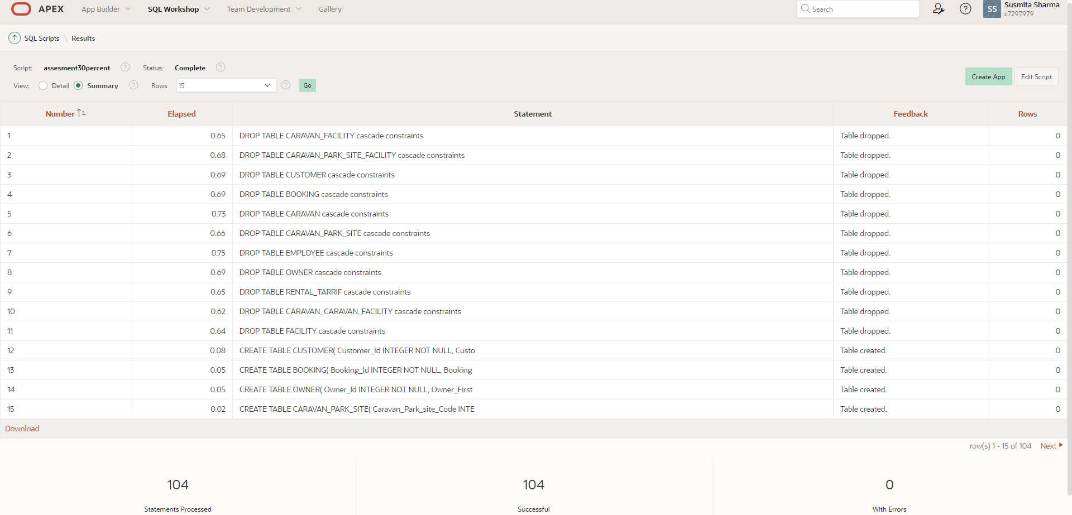

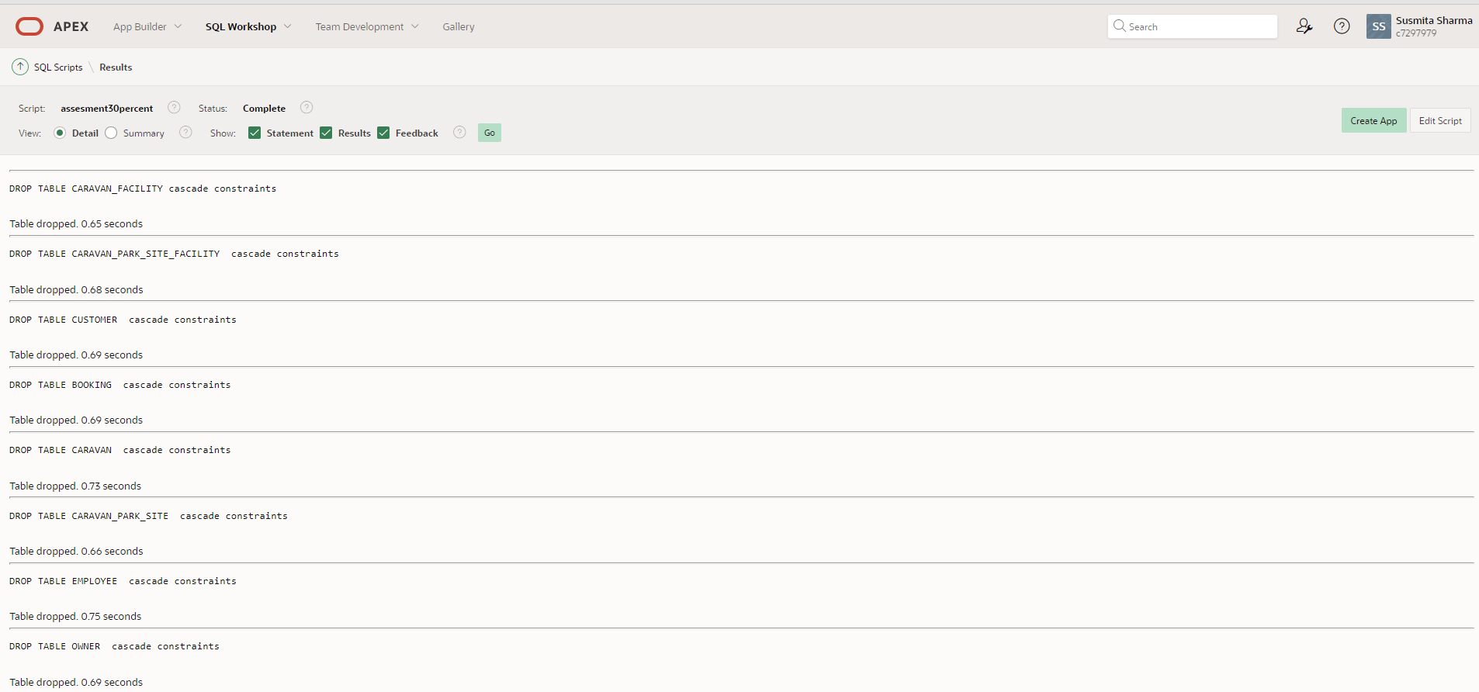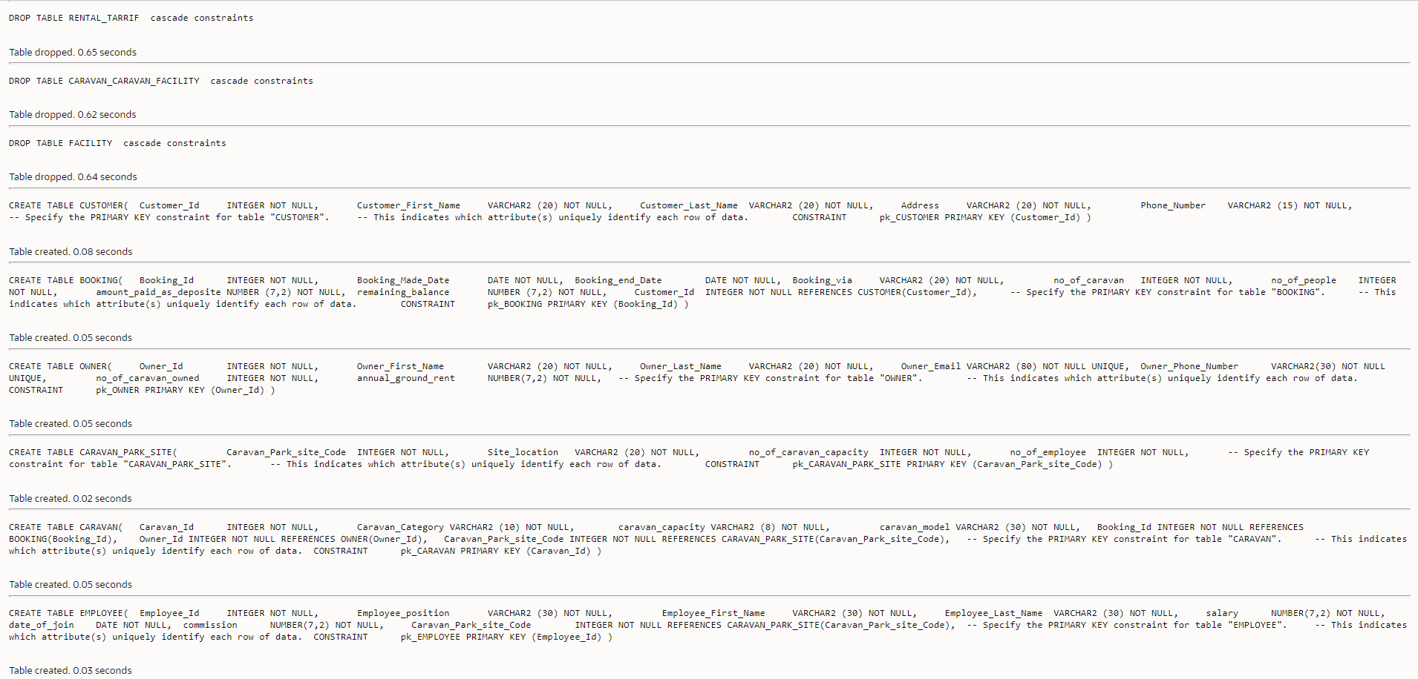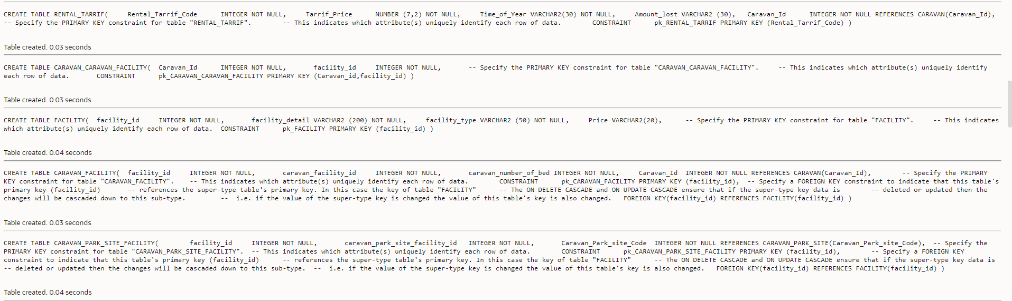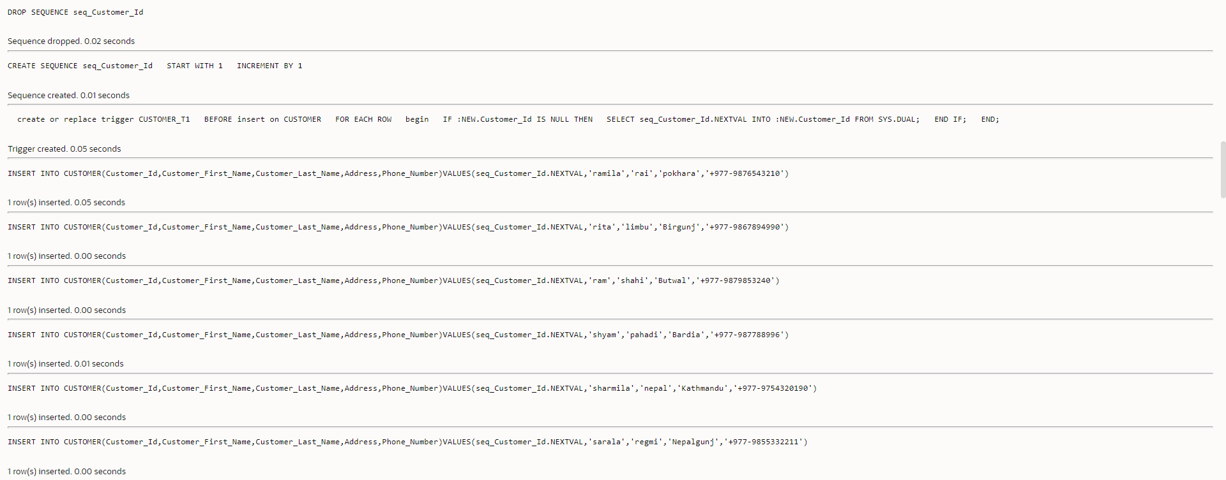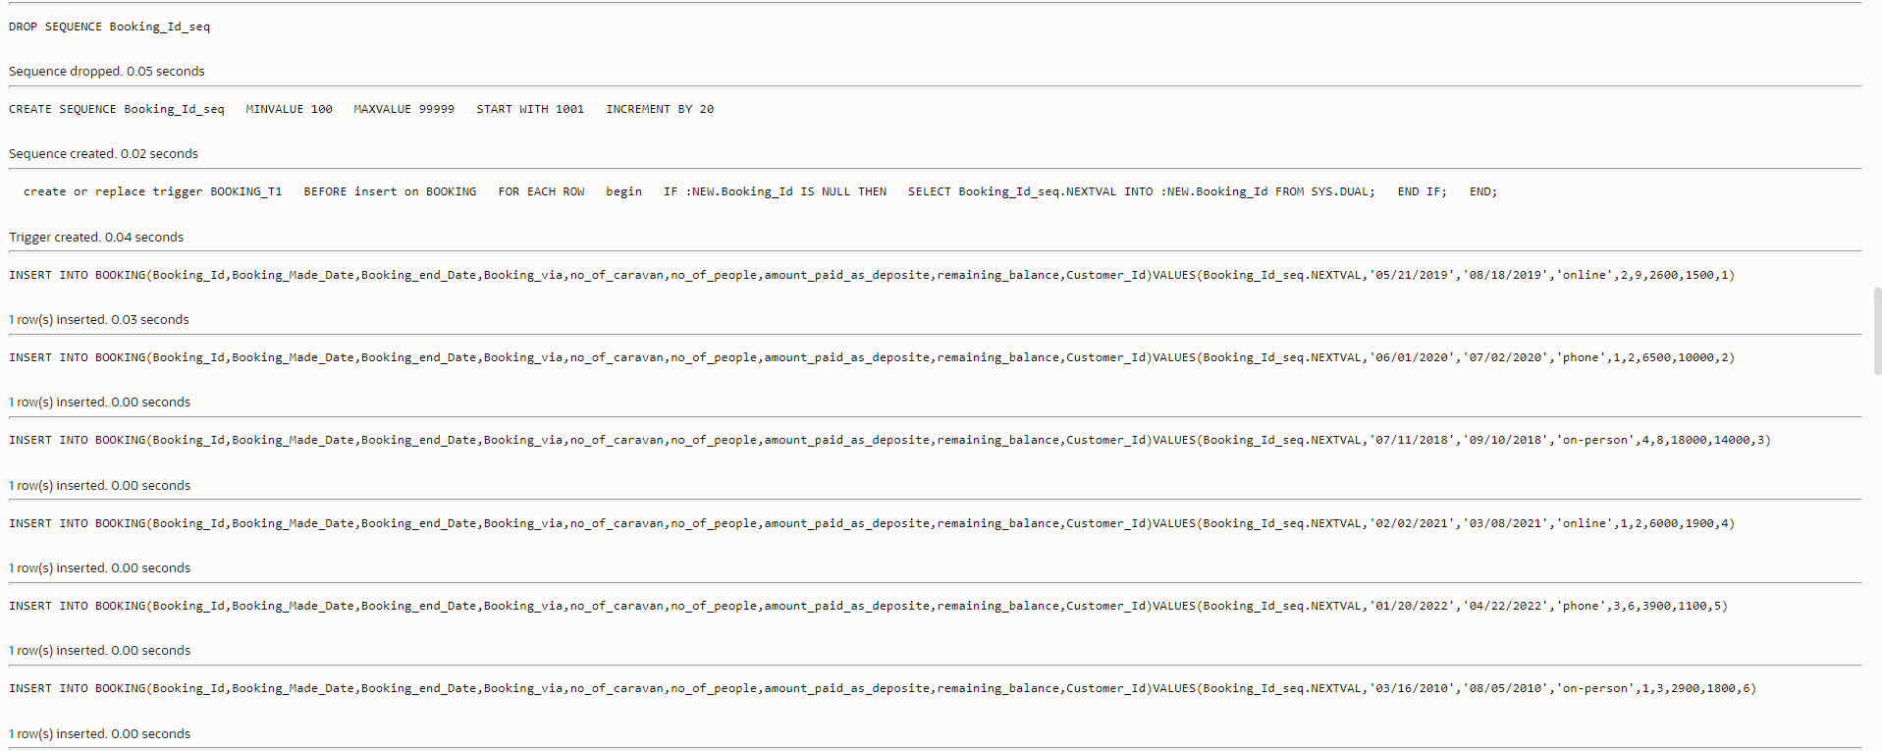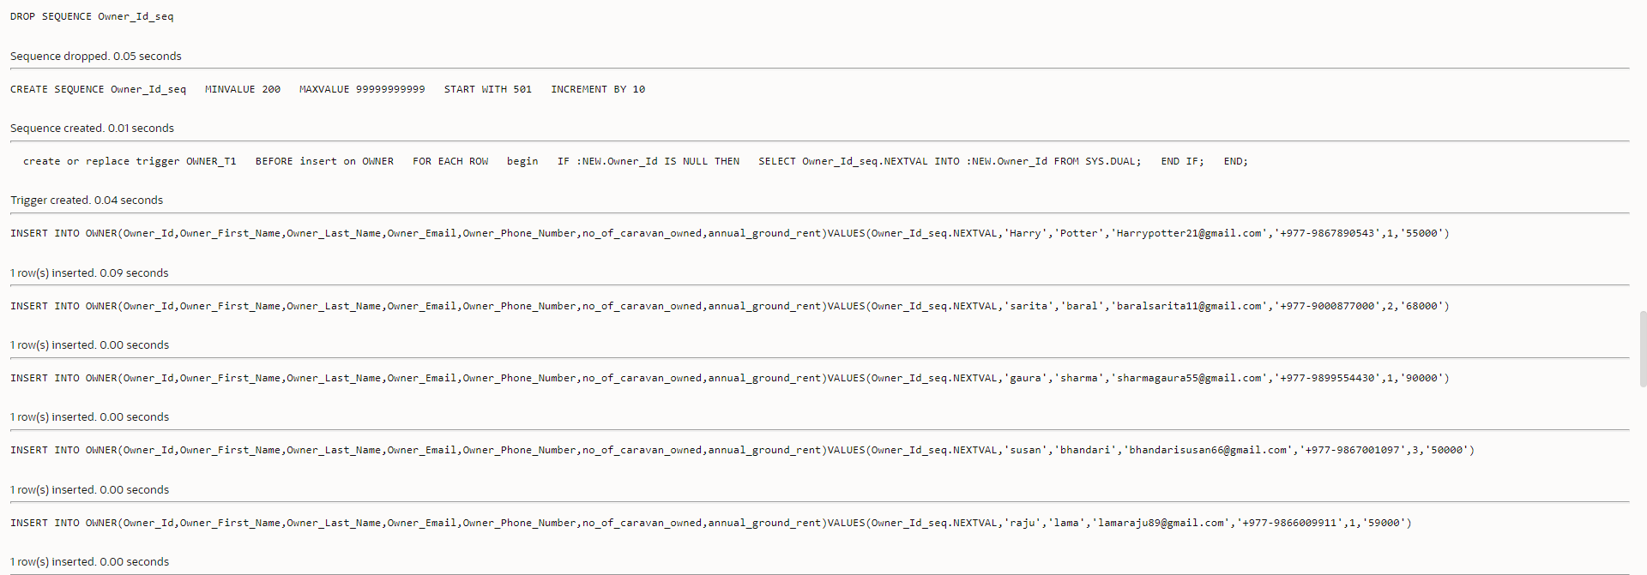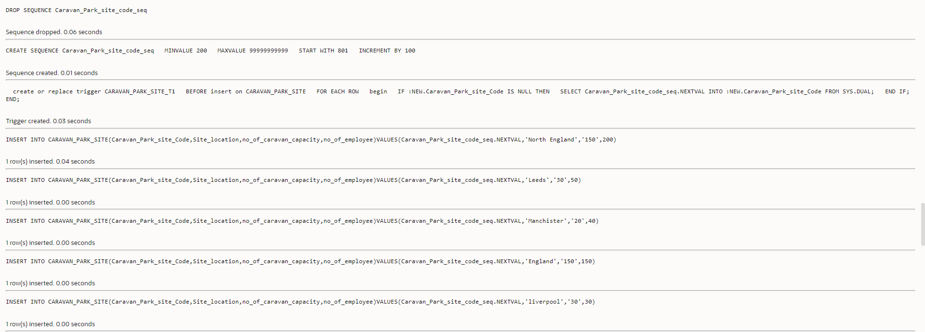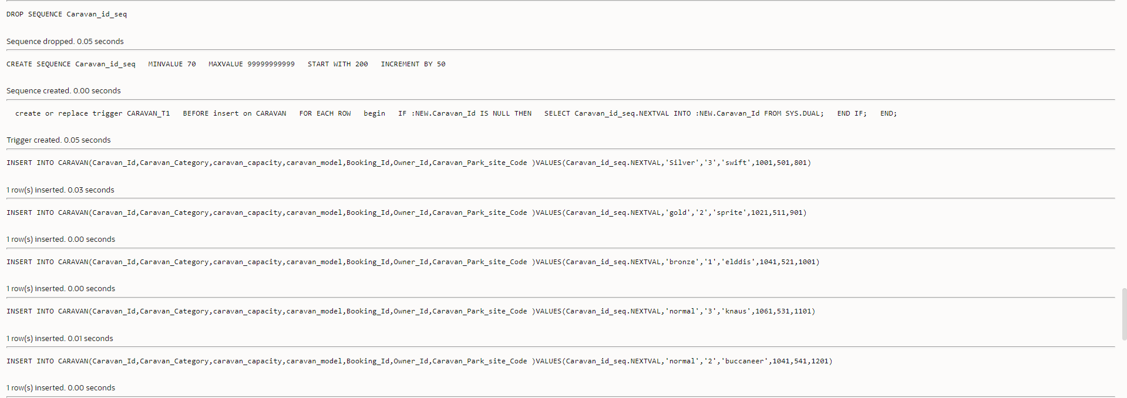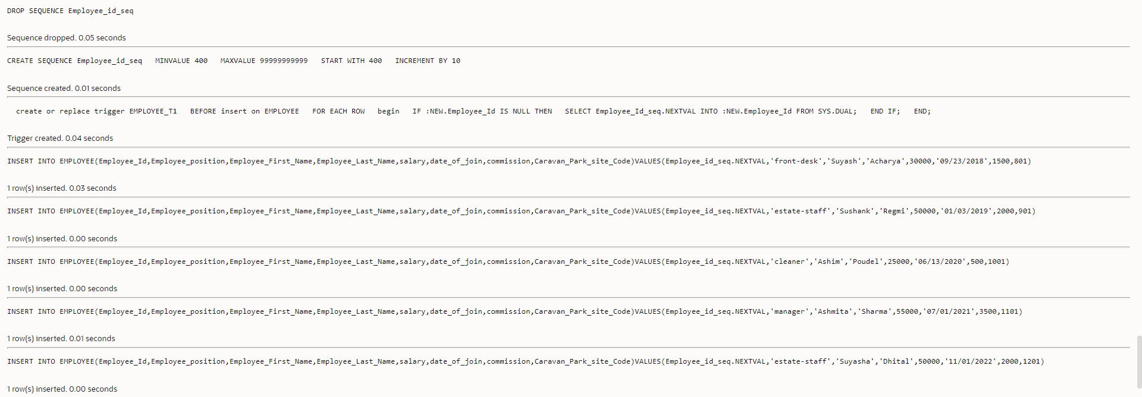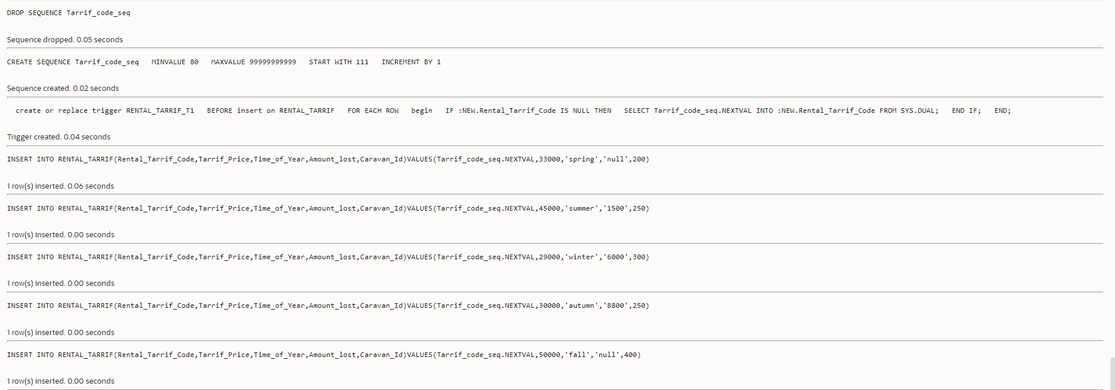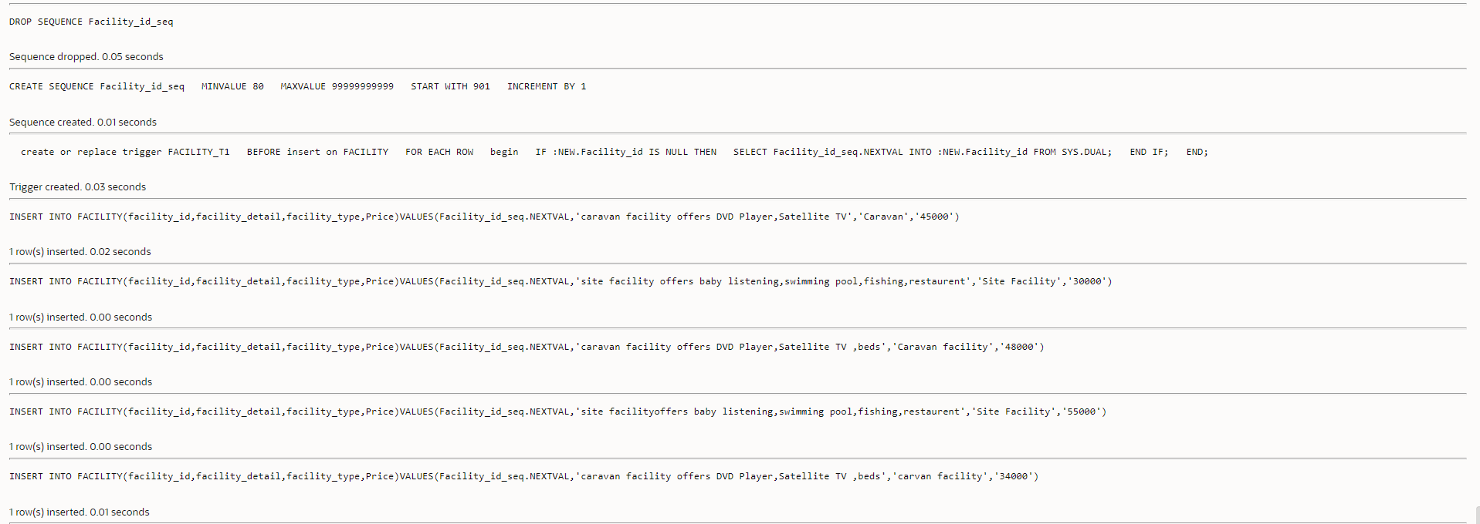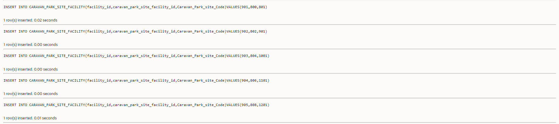

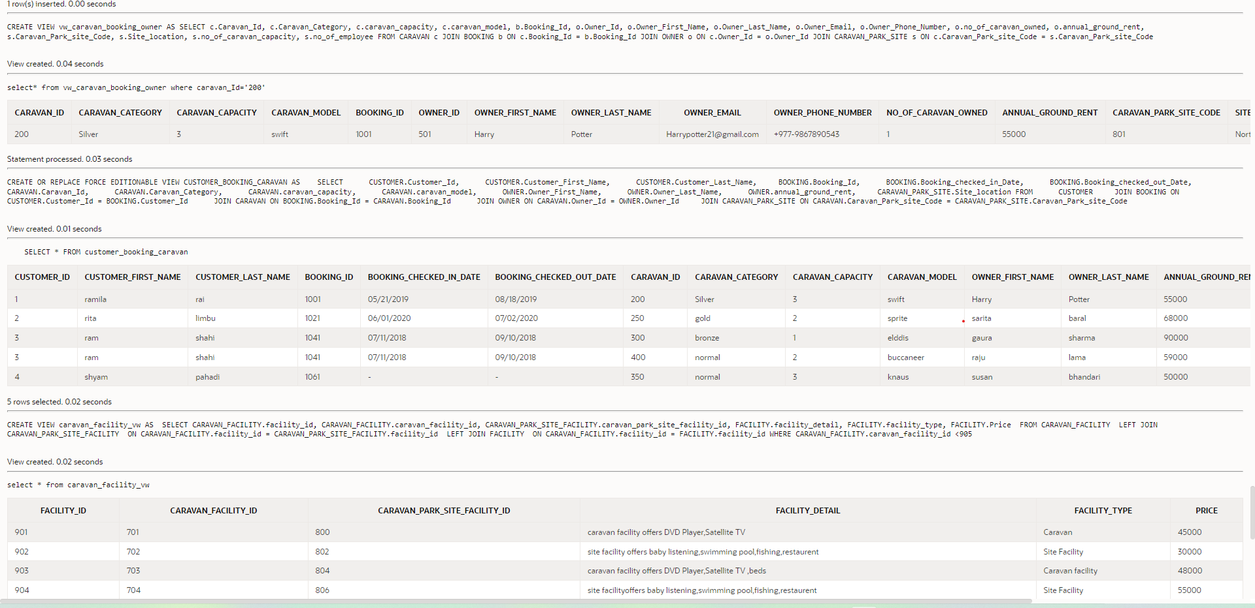
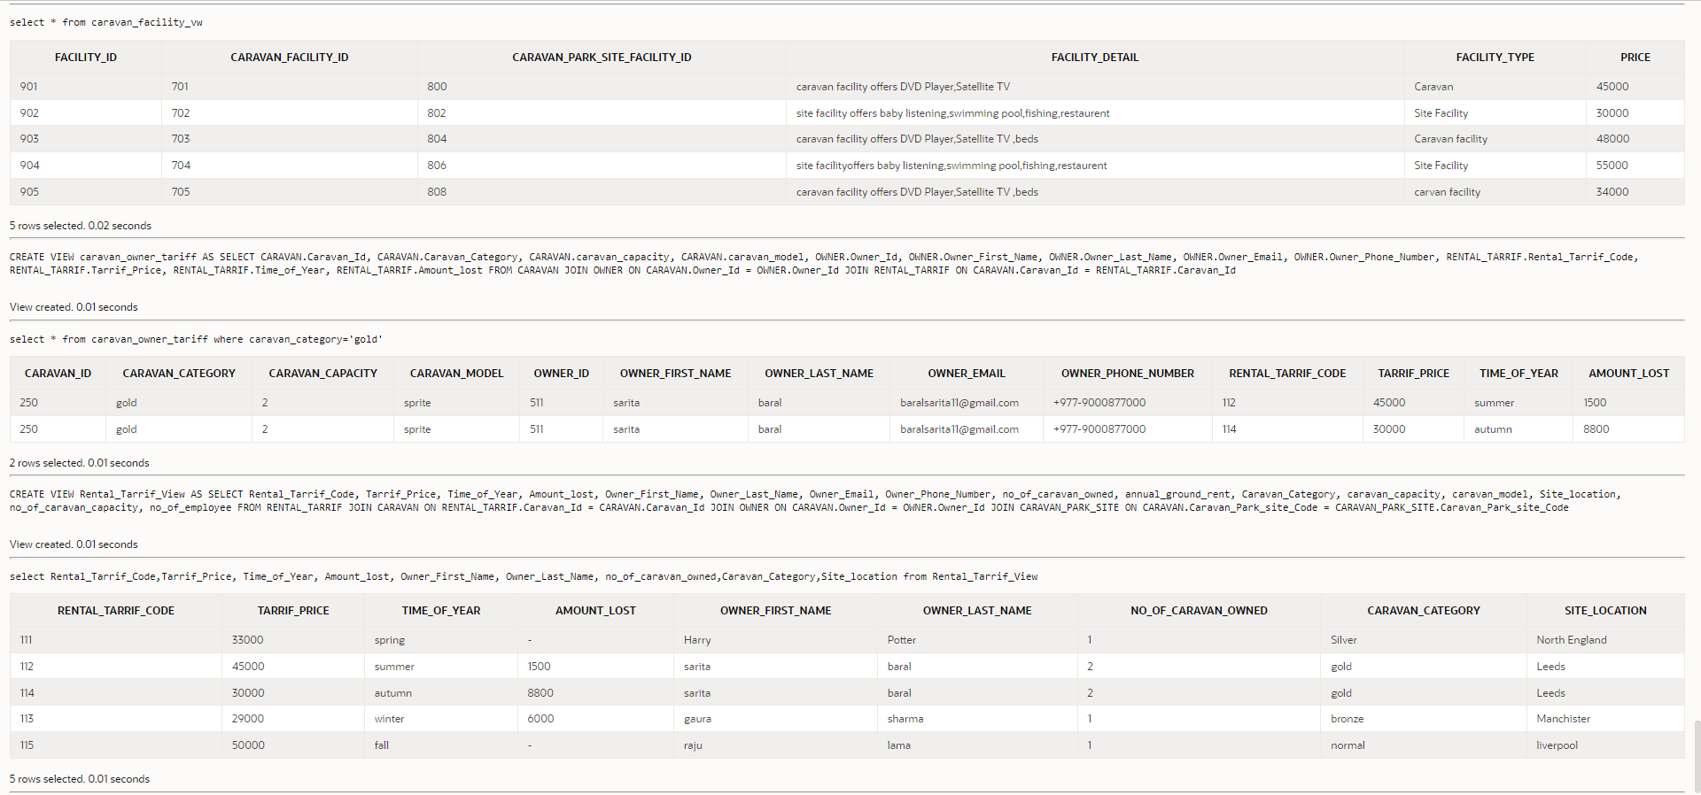
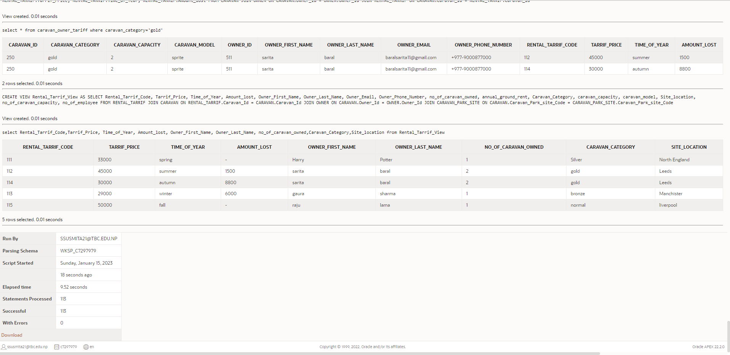
View screenshot is attached below:
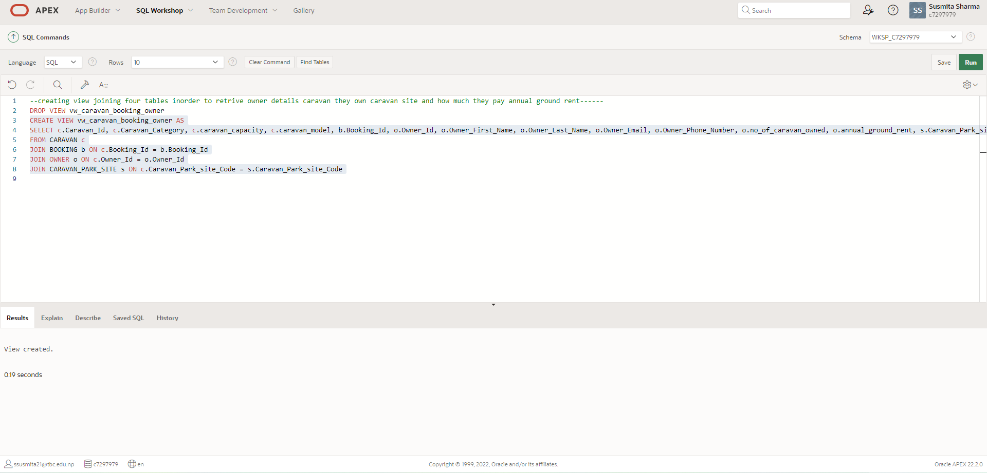

Code for testing view table screenshot:
select* from vw_caravan_booking_owner where caravan_Id='200';

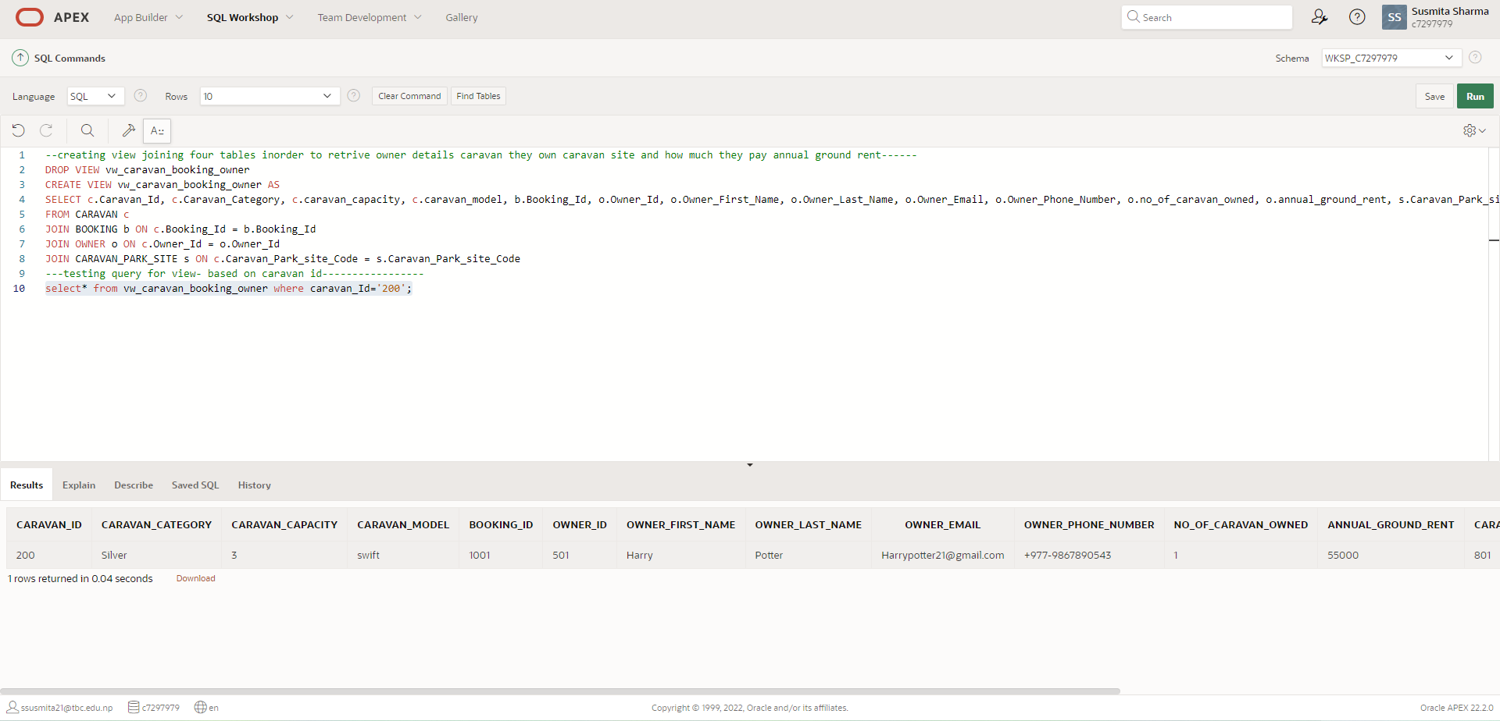

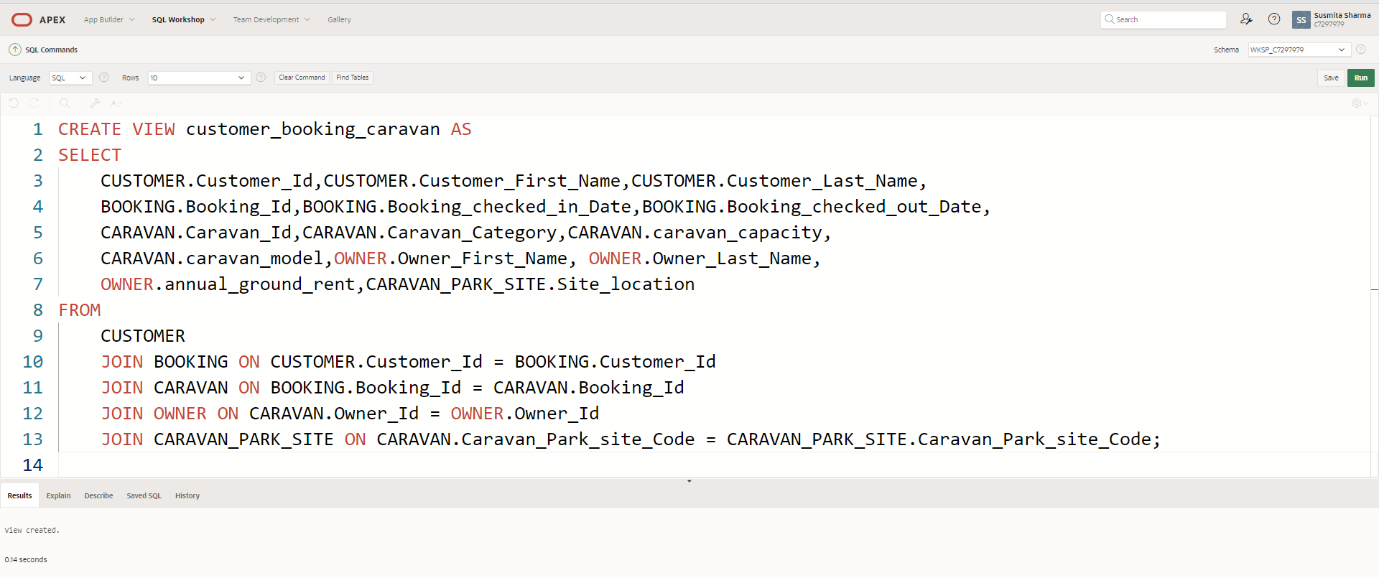

Code for testing view table screenshot:
SELECT * FROM customer_booking_caravan;
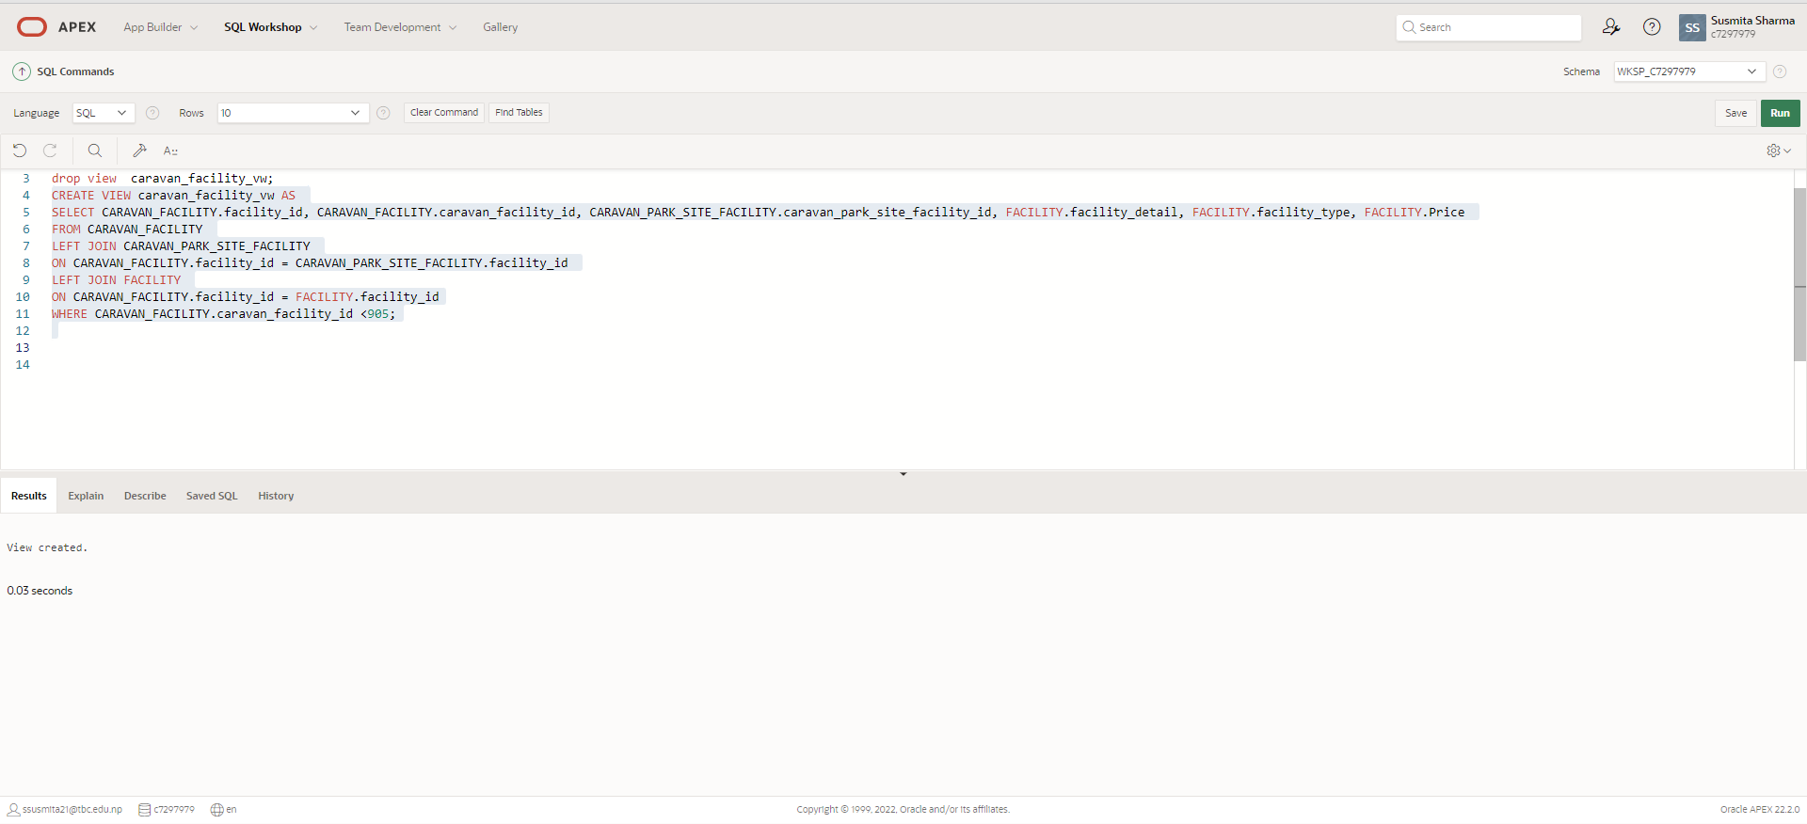

Code for testing view table screenshot:

select * from caravan_facility_vw;
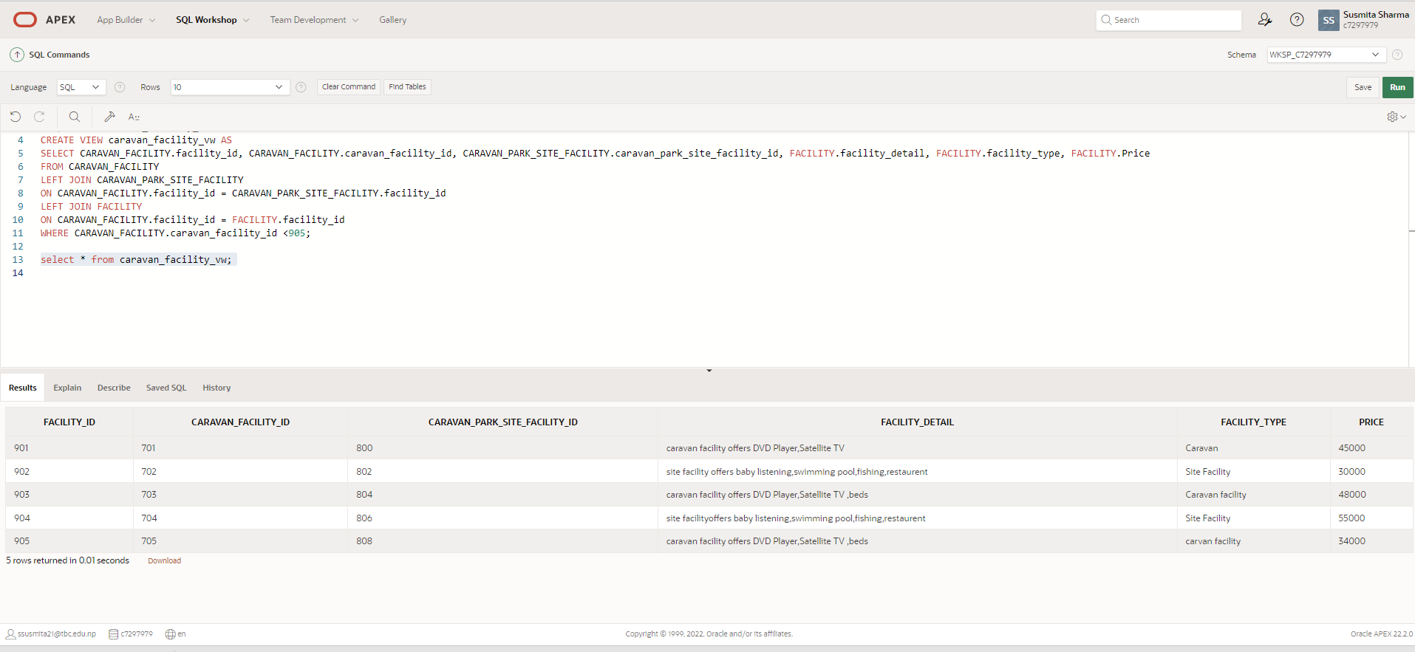

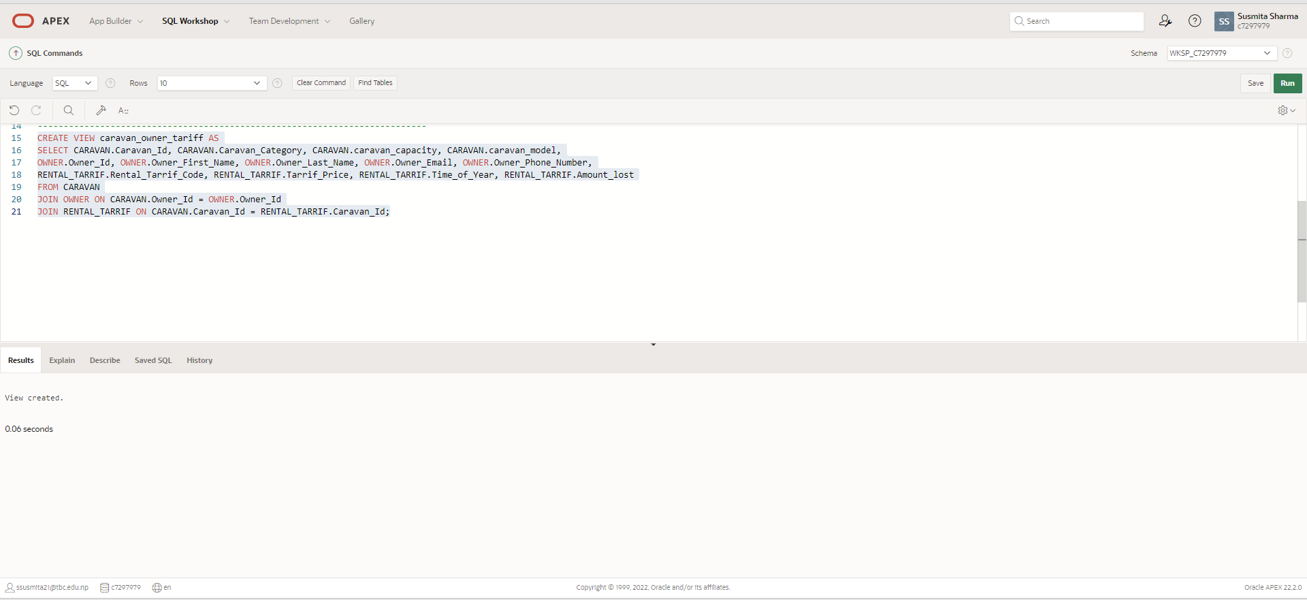

Code for testing view table screenshot:
select * from caravan_owner_tariff
where caravan_category='gold';
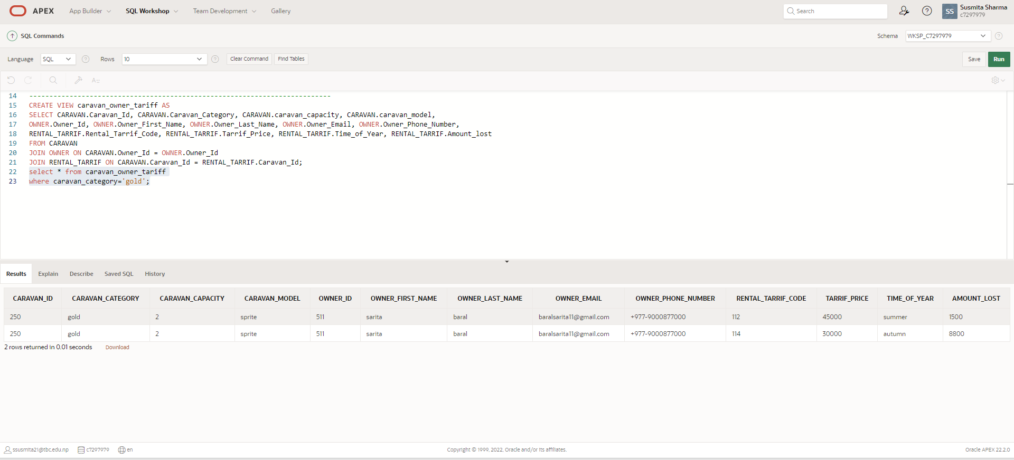
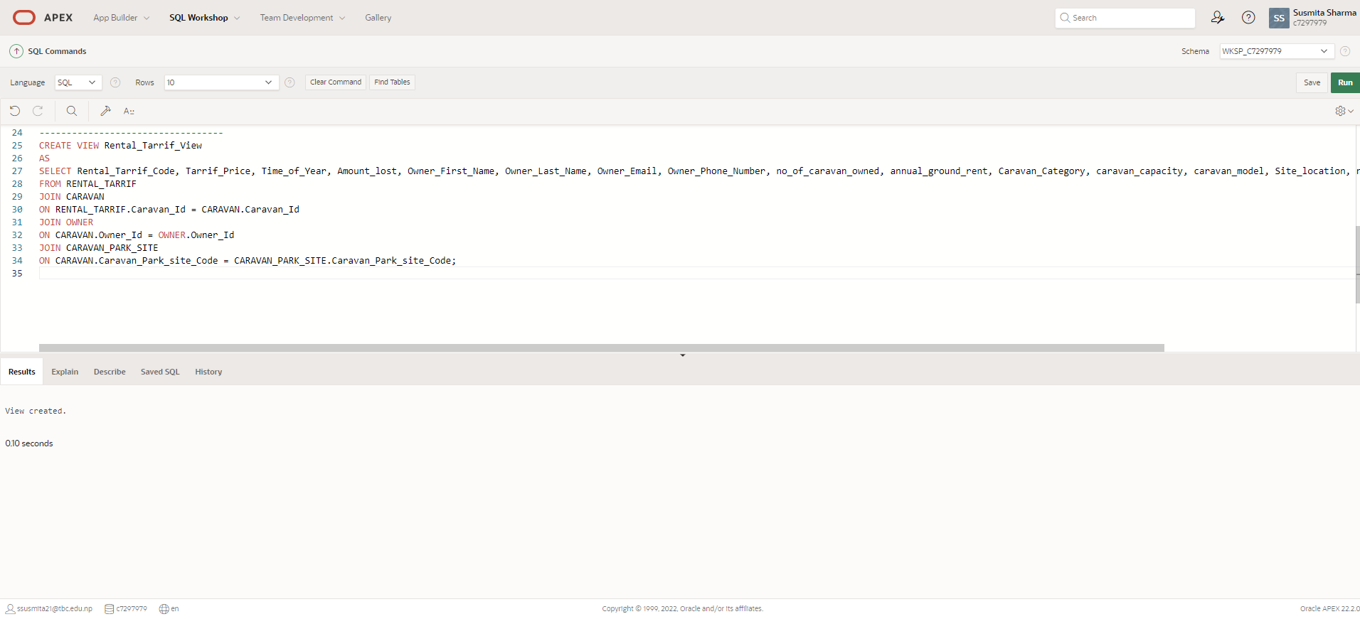

Code for testing view table screenshot:

select Rental_Tarrif_Code,Tarrif_Price, Time_of_Year, Amount_lost, Owner_First_Name, Owner_Last_Name, no_of_caravan_owned,Caravan_Category,Site_location

from Rental_Tarrif_View;
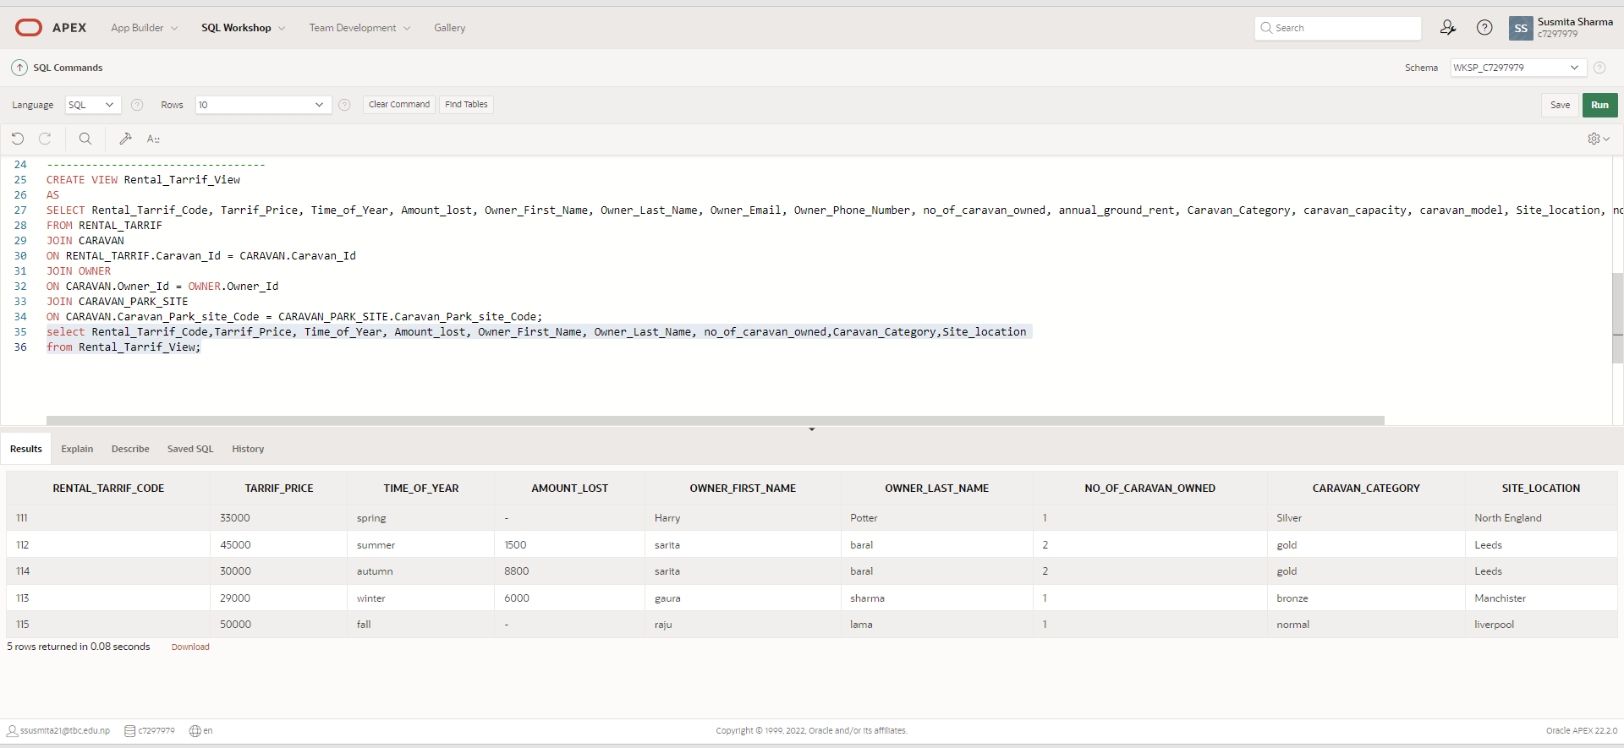

Task 2: Apex Report in Application Builder
Build a Database Application to include five Apex Reports. Your SQL statements used to build Apex Reports should be of an intermediate and advanced level.

1: SQL code and Screen shot of SQL Commands
→To display employee age andb y using to date, to char and using where clause functions.
SELECT e.Employee_First_Name, e.Employee_Last_Name, e.date_of_join,e.birth_date,
TO_CHAR(e.date_of_join, 'Month DD ,YYYY') as hire_date_formatted,
ROUND((TO_DATE(e.date_of_join, 'MM-DD-YYYY') - TO_DATE(e.birth_date, 'MM-DD-YYYY'))/365.25) as age_at_hire
FROM employee e
where employee_position='manager';
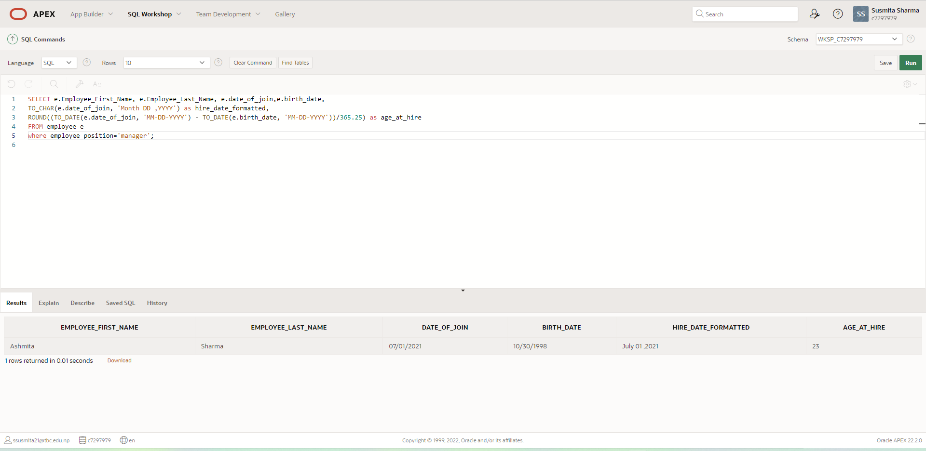
Report view in Application Builder

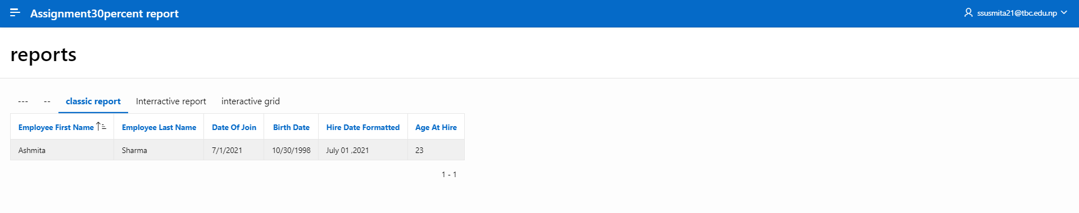
→Details on customer an their deposite amount using sum function.
SELECT CUSTOMER.Customer_First_Name, CUSTOMER.Customer_Last_Name, CARAVAN.Caravan_Category,SUM((BOOKING.amount_paid_as_deposite+BOOKING.remaining_balance)) as total_deposit,CARAVAN_PARK_SITE.Site_location
FROM CUSTOMER
INNER JOIN BOOKING
ON CUSTOMER.Customer_Id = BOOKING.Customer_Id
INNER JOIN CARAVAN
ON BOOKING.Booking_Id = CARAVAN.Booking_Id
INNER JOIN CARAVAN_PARK_SITE
ON CARAVAN.Caravan_Park_site_Code = CARAVAN_PARK_SITE.Caravan_Park_site_Code
GROUP BY CUSTOMER.Customer_First_Name, CUSTOMER.Customer_Last_Name, CARAVAN.Caravan_Category,CARAVAN_PARK_SITE.Site_location;
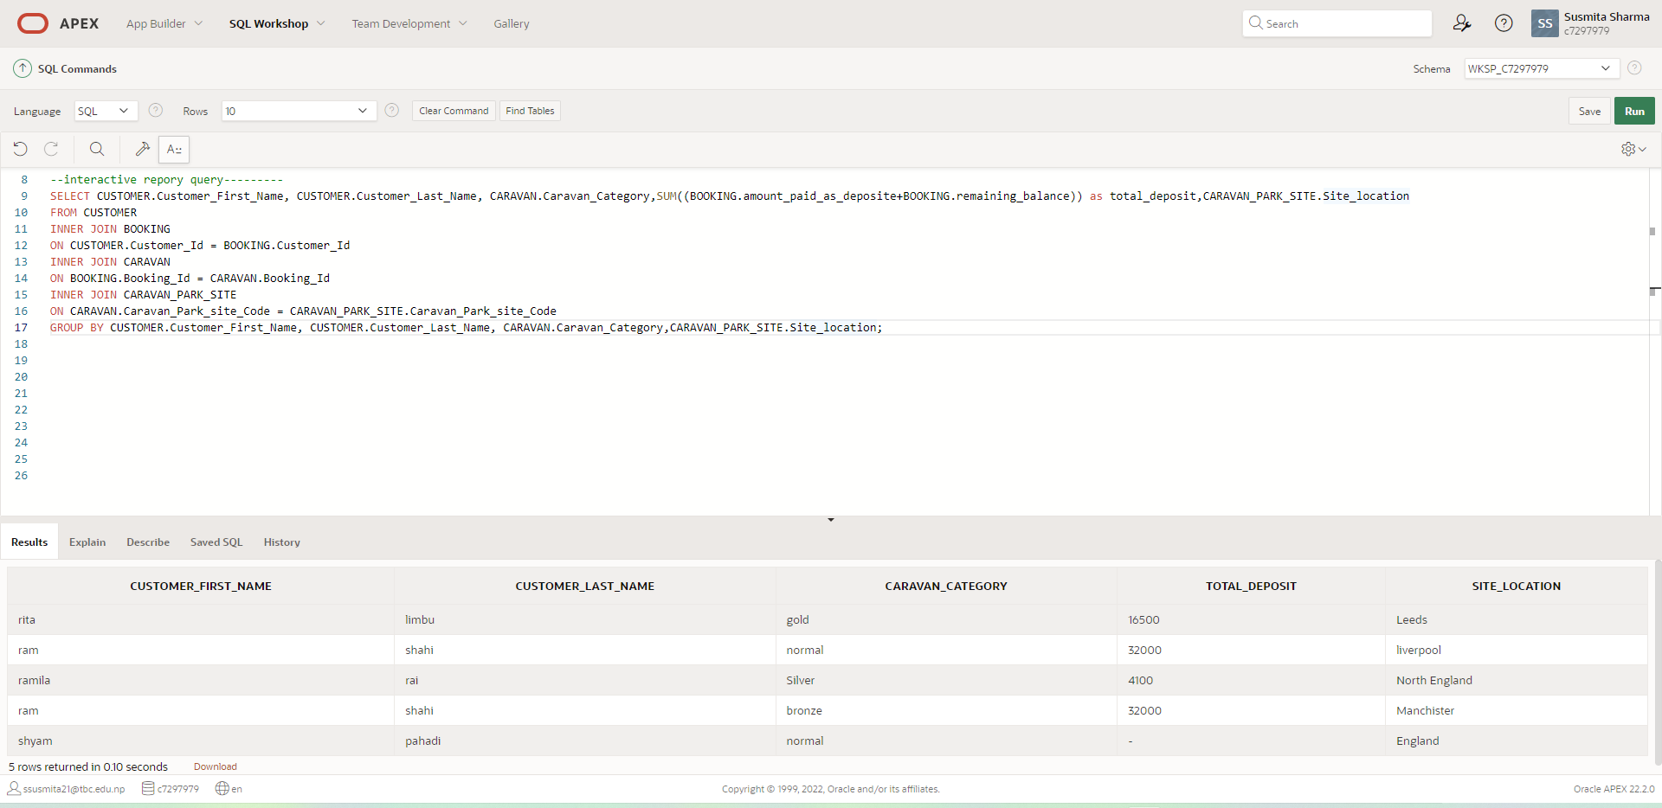
Report view in Application Builder
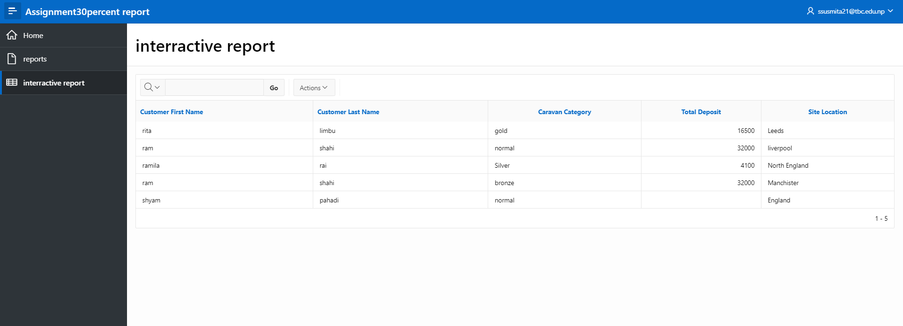

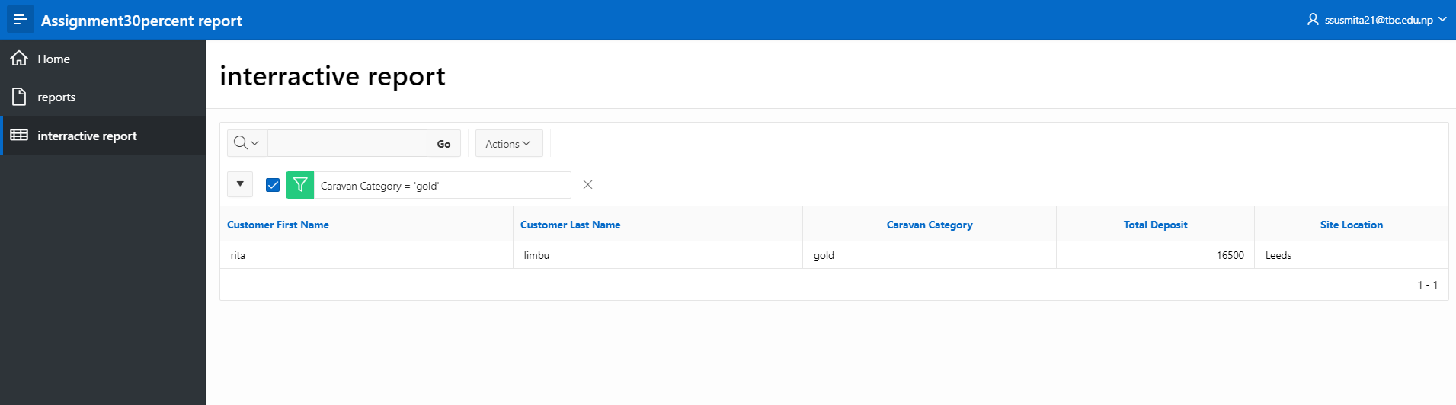
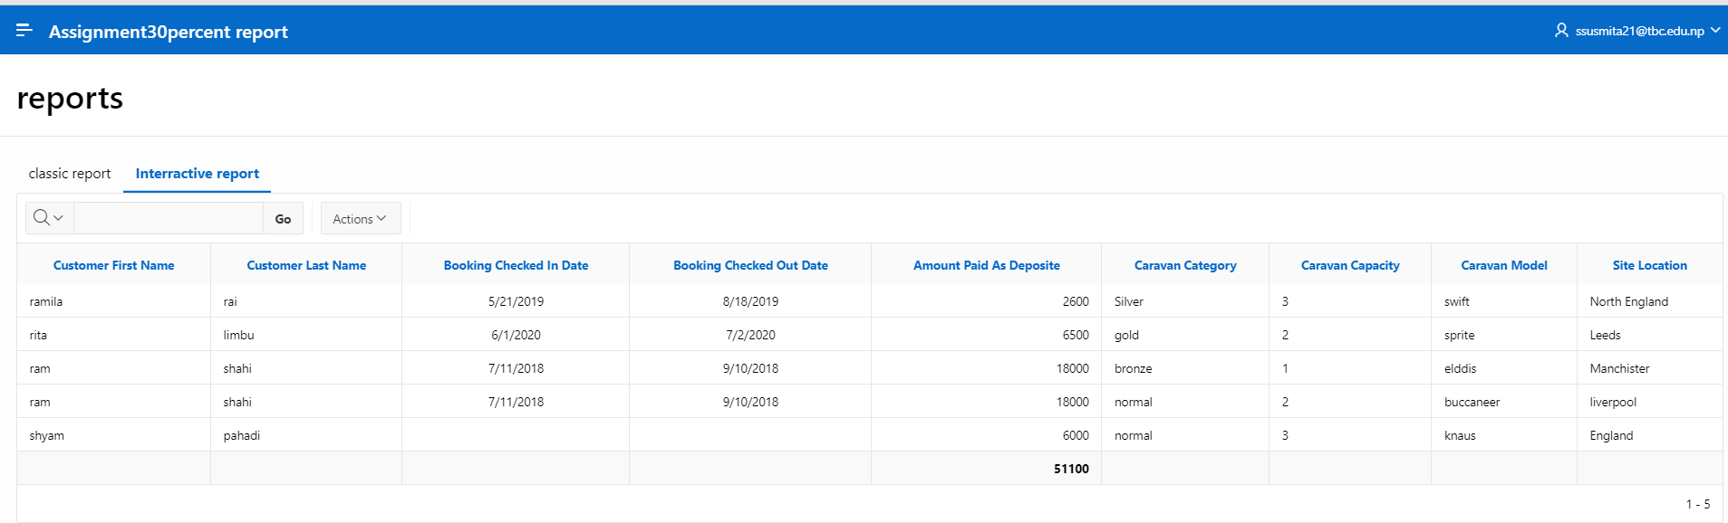
→To display number of caravan by count function .
SELECT RENTAL_TARRIF.Tarrif_Price,RENTAL_TARRIF.Time_of_Year,CARAVAN.Caravan_Category,
COUNT(DISTINCT CARAVAN.Caravan_Id) as Caravan_number_Count
FROM RENTAL_TARRIF
JOIN CARAVAN ON RENTAL_TARRIF.Caravan_Id = CARAVAN.Caravan_Id
JOIN CARAVAN_FACILITY ON CARAVAN.Caravan_Id = CARAVAN_FACILITY.Caravan_Id
JOIN CARAVAN_CARAVAN_FACILITY ON CARAVAN.Caravan_Id = CARAVAN_CARAVAN_FACILITY.Caravan_Id AND CARAVAN_FACILITY.facility_id=CARAVAN_CARAVAN_FACILITY.facility_id
GROUP BY RENTAL_TARRIF.Tarrif_Price,RENTAL_TARRIF.Time_of_Year,CARAVAN.Caravan_Category;
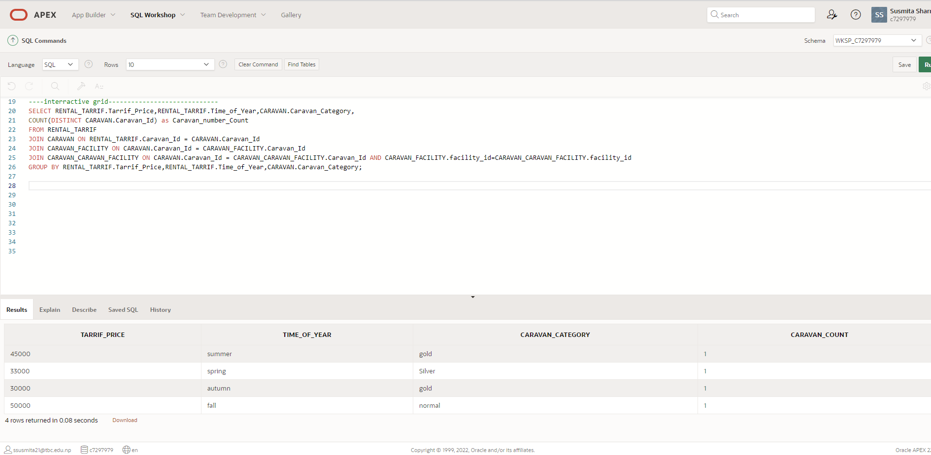

Report view in Application Builder
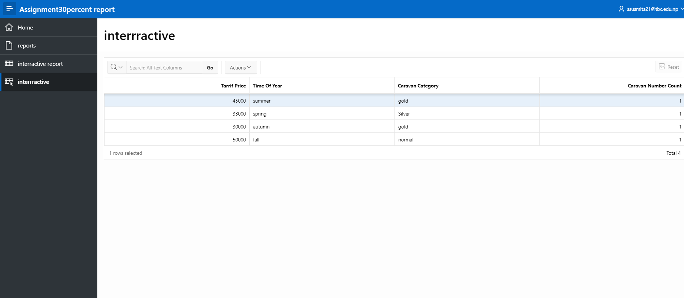

→To display caravan and the facility it provides the count of number of bed each caravan has to offer.
SELECT CARAVAN_CARAVAN_FACILITY.Caravan_Id, FACILITY.facility_detail,count(CARAVAN_FACILITY.caravan_number_of_bed) as number_of_bed
FROM CARAVAN_CARAVAN_FACILITY
LEFT JOIN FACILITY ON CARAVAN_CARAVAN_FACILITY.facility_id = FACILITY.facility_id
LEFT JOIN CARAVAN_FACILITY ON FACILITY.facility_id=CARAVAN_FACILITY.facility_id
GROUP BY CARAVAN_CARAVAN_FACILITY.Caravan_Id, FACILITY.facility_detail;
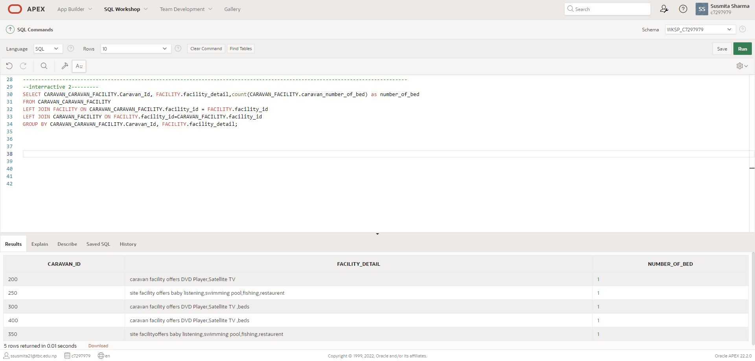

Report view in Application Builder
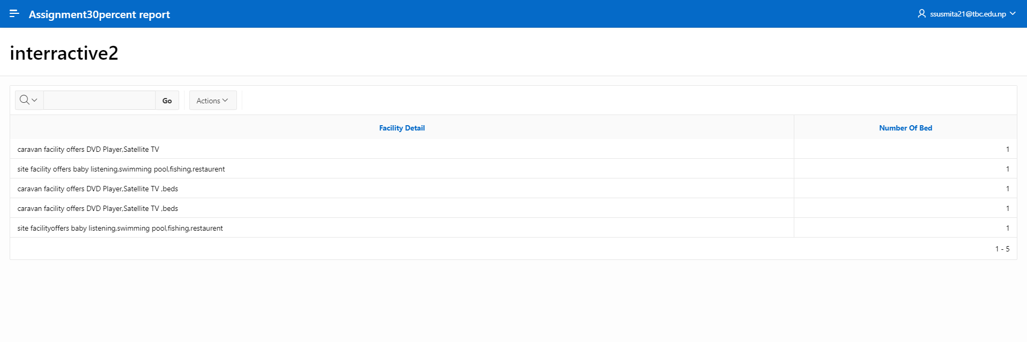
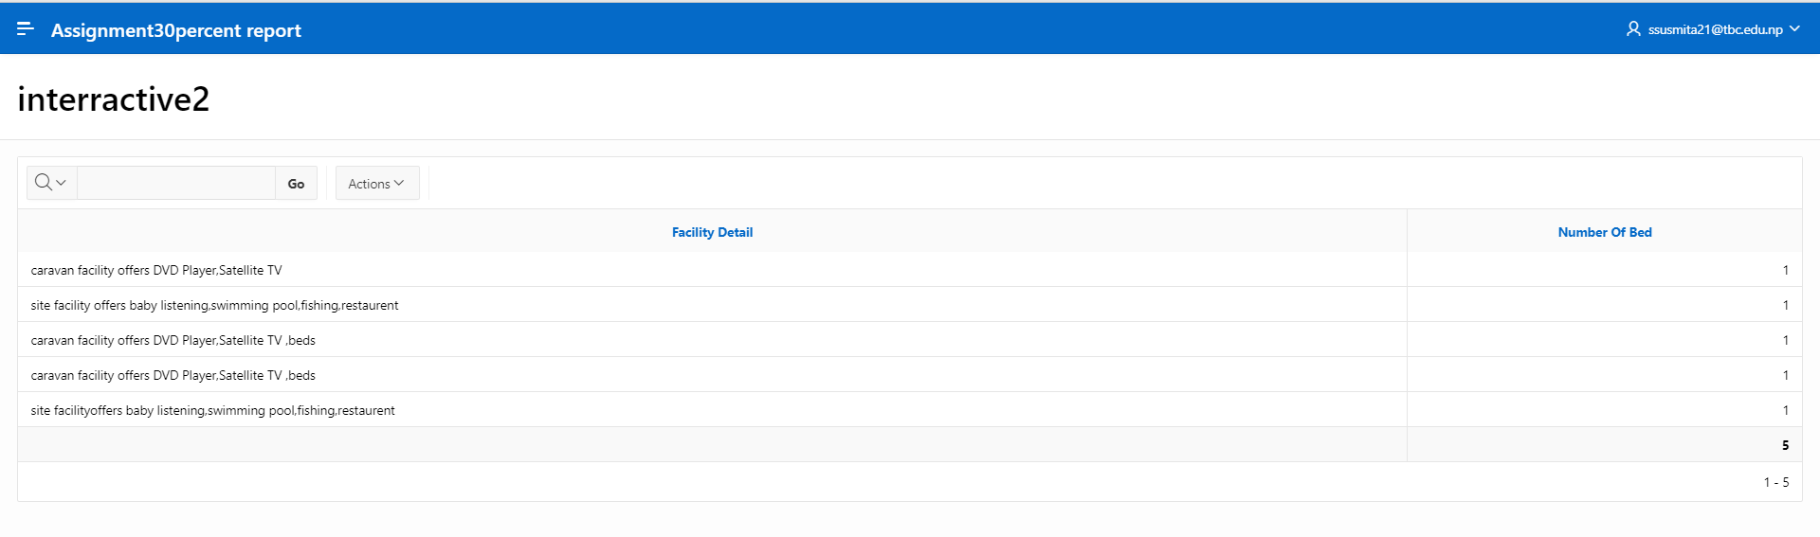
→ Display classic report of customer their booking details with caravan using group by clause.
SELECT CUSTOMER.Customer_First_Name,CUSTOMER.Customer_Last_Name, BOOKING.Booking_checked_in_Date,BOOKING.Booking_checked_out_Date,CARAVAN.Caravan_Category, CARAVAN.caravan_capacity, CARAVAN.caravan_model
FROM CUSTOMER
LEFT JOIN BOOKING
ON CUSTOMER.Customer_Id = BOOKING.Customer_Id
LEFT JOIN CARAVAN
ON BOOKING.Booking_Id = CARAVAN.Booking_Id
GROUP BY CUSTOMER.Customer_First_Name,CUSTOMER.Customer_Last_Name, BOOKING.Booking_checked_in_Date,BOOKING.Booking_checked_out_Date,CARAVAN.Caravan_Category, CARAVAN.caravan_capacity, CARAVAN.caravan_model;

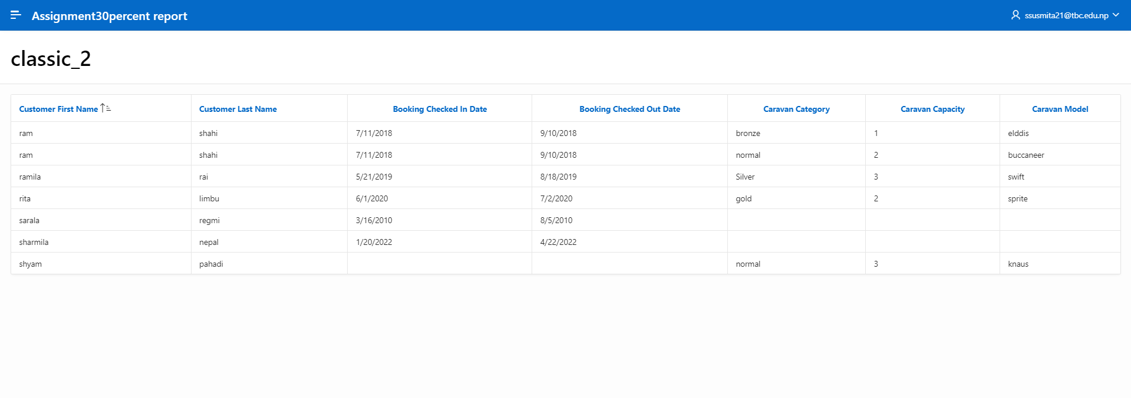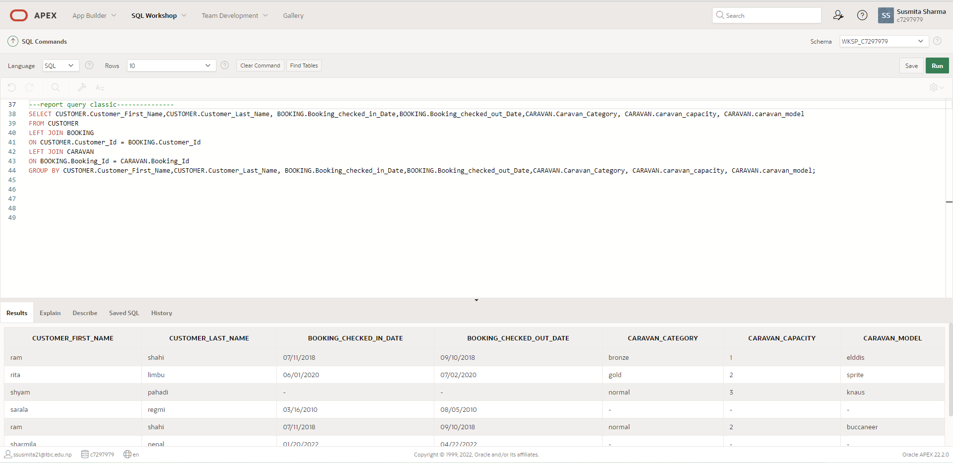

Report view in Application Builder

Bibliography

Harvard style

Appendixes
DDL and DML code
--------------------------------------------------------------
-- Database creation Script

-- Auto-Generated by QSEE-SuperLite (c) 2001-2004 QSEE-Technologies Ltd.

-- Verbose generation: ON

-- note: spaces within table/column names have been replaced by underscores (_)

-- Target DB: SQL2

-- Entity Model :Happy Holiday EERD

-- To drop the tables generated by this script run -
-- 'C:\Users\DELL\Desktop\happyholiday_drop.sql'

--------------------------------------------------------------
DROP TABLE CARAVAN_FACILITY cascade constraints;

DROP TABLE CARAVAN_PARK_SITE_FACILITY cascade constraints;

DROP TABLE CUSTOMER cascade constraints;

DROP TABLE BOOKING cascade constraints;

DROP TABLE CARAVAN cascade constraints;

DROP TABLE CARAVAN_PARK_SITE cascade constraints;

DROP TABLE EMPLOYEE cascade constraints;

DROP TABLE OWNER cascade constraints;

DROP TABLE RENTAL_TARRIF cascade constraints;

DROP TABLE CARAVAN_CARAVAN_FACILITY cascade constraints;

DROP TABLE FACILITY cascade constraints;

--------------------------------------------------------------
-- Table Creation --

-- Each entity on the model is represented by a table that needs to be created within the Database.
-- Within SQL new tables are created using the CREATE TABLE command.
-- When a table is created its name and its attributes are defined.
-- The values of which are derived from those specified on the model.
-- Certain constraints are sometimes also specified, such as identification of primary keys.

-- Create a Database table to represent the "CUSTOMER" entity.
CREATE TABLE CUSTOMER(
Customer_Id INTEGER NOT NULL,
Customer_First_Name VARCHAR2 (20) NOT NULL,
Customer_Last_Name VARCHAR2 (20) NOT NULL,
Address VARCHAR2 (20) NOT NULL,
Phone_Number VARCHAR2 (15) NOT NULL,

-- Specify the PRIMARY KEY constraint for table "CUSTOMER".
-- This indicates which attribute(s) uniquely identify each row of data.
CONSTRAINT pk_CUSTOMER PRIMARY KEY (Customer_Id)
);
-- Create a Database table to represent the "CARAVAN" entity.

-- Create a Database table to represent the "BOOKING" entity.
CREATE TABLE BOOKING(
Booking_Id INTEGER NOT NULL,
Booking_date DATE,
Booking_checked_in_Date DATE,
Booking_checked_out_Date DATE,
Booking_via VARCHAR2 (20) NOT NULL,
no_of_caravan INTEGER NOT NULL,
no_of_people INTEGER NOT NULL,
amount_paid_as_deposite NUMBER (7,2) NOT NULL,
remaining_balance NUMBER (7,2),
Customer_Id INTEGER NOT NULL REFERENCES CUSTOMER(Customer_Id),
-- Specify the PRIMARY KEY constraint for table "BOOKING".
-- This indicates which attribute(s) uniquely identify each row of data.
CONSTRAINT pk_BOOKING PRIMARY KEY (Booking_Id)
);
-- Create a Database table to represent the "OWNER" entity.
CREATE TABLE OWNER(
Owner_Id INTEGER NOT NULL,
Owner_First_Name VARCHAR2 (20) NOT NULL,
Owner_Last_Name VARCHAR2 (20) NOT NULL,
Owner_Email VARCHAR2 (80) NOT NULL UNIQUE,
Owner_Phone_Number VARCHAR2(30) NOT NULL UNIQUE,
no_of_caravan_owned INTEGER NOT NULL,
annual_ground_rent NUMBER(7,2) NOT NULL,
-- Specify the PRIMARY KEY constraint for table "OWNER".
-- This indicates which attribute(s) uniquely identify each row of data.
CONSTRAINT pk_OWNER PRIMARY KEY (Owner_Id)
);
-- Create a Database table to represent the "CARAVAN_PARK_SITE" entity.
CREATE TABLE CARAVAN_PARK_SITE(
Caravan_Park_site_Code INTEGER NOT NULL,
Site_location VARCHAR2 (20) NOT NULL,
no_of_caravan_capacity INTEGER NOT NULL,
no_of_employee INTEGER NOT NULL,

-- Specify the PRIMARY KEY constraint for table "CARAVAN_PARK_SITE".
-- This indicates which attribute(s) uniquely identify each row of data.
CONSTRAINT pk_CARAVAN_PARK_SITE PRIMARY KEY (Caravan_Park_site_Code)
);

CREATE TABLE CARAVAN(
Caravan_Id INTEGER NOT NULL,
Caravan_Category VARCHAR2 (10) NOT NULL,
caravan_capacity VARCHAR2 (8) NOT NULL,
caravan_model VARCHAR2 (30) NOT NULL,
Booking_Id INTEGER NOT NULL REFERENCES BOOKING(Booking_Id),
Owner_Id INTEGER NOT NULL REFERENCES OWNER(Owner_Id),
Caravan_Park_site_Code INTEGER NOT NULL REFERENCES CARAVAN_PARK_SITE(Caravan_Park_site_Code),
-- Specify the PRIMARY KEY constraint for table "CARAVAN".
-- This indicates which attribute(s) uniquely identify each row of data.
CONSTRAINT pk_CARAVAN PRIMARY KEY (Caravan_Id)
);

-- Create a Database table to represent the "EMPLOYEE" entity.
CREATE TABLE EMPLOYEE(
Employee_Id INTEGER NOT NULL,
Employee_position VARCHAR2 (30) NOT NULL,
Employee_First_Name VARCHAR2 (30) NOT NULL,
Employee_Last_Name VARCHAR2 (30) NOT NULL,
salary NUMBER(7,2) NOT NULL,
date_of_join DATE NOT NULL,
birth_date date not null,
commission NUMBER(7,2),
Caravan_Park_site_Code INTEGER NOT NULL REFERENCES CARAVAN_PARK_SITE(Caravan_Park_site_Code),
-- Specify the PRIMARY KEY constraint for table "EMPLOYEE".
-- This indicates which attribute(s) uniquely identify each row of data.
CONSTRAINT pk_EMPLOYEE PRIMARY KEY (Employee_Id)
);

-- Create a Database table to represent the "RENTAL_TARRIF" entity.
CREATE TABLE RENTAL_TARRIF(
Rental_Tarrif_Code INTEGER NOT NULL,
Tarrif_Price NUMBER (7,2) NOT NULL,
Time_of_Year VARCHAR2(30) NOT NULL,
Amount_lost VARCHAR2 (30),
Caravan_Id INTEGER NOT NULL REFERENCES CARAVAN(Caravan_Id),
-- Specify the PRIMARY KEY constraint for table "RENTAL_TARRIF".
-- This indicates which attribute(s) uniquely identify each row of data.
CONSTRAINT pk_RENTAL_TARRIF PRIMARY KEY (Rental_Tarrif_Code)
);

-- Create a Database table to represent the "CARAVAN_CARAVAN_FACILITY" entity.
CREATE TABLE CARAVAN_CARAVAN_FACILITY(
Caravan_Id INTEGER NOT NULL,
facility_id INTEGER NOT NULL,
-- Specify the PRIMARY KEY constraint for table "CARAVAN_CARAVAN_FACILITY".
-- This indicates which attribute(s) uniquely identify each row of data.
CONSTRAINT pk_CARAVAN_CARAVAN_FACILITY PRIMARY KEY (Caravan_id,facility_id)
);

-- Create a Database table to represent the "FACILITY" entity.
CREATE TABLE FACILITY(
facility_id INTEGER NOT NULL,
facility_detail VARCHAR2 (200) NOT NULL,
facility_type VARCHAR2 (50) NOT NULL,
Price VARCHAR2(20),
-- Specify the PRIMARY KEY constraint for table "FACILITY".
-- This indicates which attribute(s) uniquely identify each row of data.
CONSTRAINT pk_FACILITY PRIMARY KEY (facility_id)
);

-- Create a Database table to represent the "CARAVAN_FACILITY" entity.
-- This table is representing a sub-type entity, so the primary key will be the same as that
-- defined for table "FACILITY" which represents the super-type entity.
CREATE TABLE CARAVAN_FACILITY(
facility_id INTEGER NOT NULL,
caravan_facility_id INTEGER NOT NULL,
caravan_number_of_bed INTEGER NOT NULL,
Caravan_Id INTEGER NOT NULL REFERENCES CARAVAN(Caravan_Id),

-- Specify the PRIMARY KEY constraint for table "CARAVAN_FACILITY".
-- This indicates which attribute(s) uniquely identify each row of data.
CONSTRAINT pk_CARAVAN_FACILITY PRIMARY KEY (facility_id),
-- Specify a FOREIGN KEY constraint to indicate that this table's primary key (facility_id)
-- references the super-type table's primary key. In this case the key of table "FACILITY"
-- The ON DELETE CASCADE and ON UPDATE CASCADE ensure that if the super-type key data is
-- deleted or updated then the changes will be cascaded down to this sub-type.
-- i.e. if the value of the super-type key is changed the value of this table's key is also changed.
FOREIGN KEY(facility_id) REFERENCES FACILITY(facility_id)
);

-- Create a Database table to represent the "CARAVAN_PARK_SITE_FACILITY" entity.
-- This table is representing a sub-type entity, so the primary key will be the same as that
-- defined for table "FACILITY" which represents the super-type entity.
CREATE TABLE CARAVAN_PARK_SITE_FACILITY(
facility_id INTEGER NOT NULL,
caravan_park_site_facility_id INTEGER NOT NULL,
Caravan_Park_site_Code INTEGER NOT NULL REFERENCES CARAVAN_PARK_SITE(Caravan_Park_site_Code),
-- Specify the PRIMARY KEY constraint for table "CARAVAN_PARK_SITE_FACILITY".
-- This indicates which attribute(s) uniquely identify each row of data.
CONSTRAINT pk_CARAVAN_PARK_SITE_FACILITY PRIMARY KEY (facility_id),
-- Specify a FOREIGN KEY constraint to indicate that this table's primary key (facility_id)
-- references the super-type table's primary key. In this case the key of table "FACILITY"
-- The ON DELETE CASCADE and ON UPDATE CASCADE ensure that if the super-type key data is
-- deleted or updated then the changes will be cascaded down to this sub-type.
-- i.e. if the value of the super-type key is changed the value of this table's key is also changed.
FOREIGN KEY(facility_id) REFERENCES FACILITY(facility_id)
);
----------------------------------------------------------------------------------------
--creating sequence for primary key--------------
DROP SEQUENCE seq_Customer_Id;
CREATE SEQUENCE seq_Customer_Id
START WITH 1
INCREMENT BY 1;

----------------------------------------------------------------------------------------------------------------------------------------------------------------------------
--creating trigger to validate-----
create or replace trigger CUSTOMER_T1
BEFORE insert on CUSTOMER
FOR EACH ROW
begin
:NEW.Customer_Id :=seq_Customer_Id.NEXTVAL;
END;
/

--inserting values into customer table-------------------------------

INSERT INTO CUSTOMER(Customer_Id,Customer_First_Name,Customer_Last_Name,Address,Phone_Number)VALUES(seq_Customer_Id.NEXTVAL,'ramila','rai','pokhara','+977-9876543210');
INSERT INTO CUSTOMER(Customer_Id,Customer_First_Name,Customer_Last_Name,Address,Phone_Number)VALUES(seq_Customer_Id.NEXTVAL,'rita','limbu','Birgunj','+977-9867894990');
INSERT INTO CUSTOMER(Customer_Id,Customer_First_Name,Customer_Last_Name,Address,Phone_Number)VALUES(seq_Customer_Id.NEXTVAL,'ram','shahi','Butwal','+977-9879853240');
INSERT INTO CUSTOMER(Customer_Id,Customer_First_Name,Customer_Last_Name,Address,Phone_Number)VALUES(seq_Customer_Id.NEXTVAL,'shyam','pahadi','Bardia','+977-987788996');
INSERT INTO CUSTOMER(Customer_Id,Customer_First_Name,Customer_Last_Name,Address,Phone_Number)VALUES(seq_Customer_Id.NEXTVAL,'sharmila','nepal','Kathmandu','+977-9754320190');
INSERT INTO CUSTOMER(Customer_Id,Customer_First_Name,Customer_Last_Name,Address,Phone_Number)VALUES(seq_Customer_Id.NEXTVAL,'sarala','regmi','Nepalgunj','+977-9855332211');
---------------------------------------------------------------------------------------------------------------------------------------------------------------------------------

--creating sequence for primary key--------------
DROP SEQUENCE Booking_Id_seq;
CREATE SEQUENCE Booking_Id_seq
MINVALUE 100
MAXVALUE 99999
START WITH 1001
INCREMENT BY 20;
----------------------------
--creating trigger to validate-----------------
create or replace trigger BOOKING_T1
BEFORE insert on BOOKING
FOR EACH ROW
begin
:NEW.Booking_Id:=Booking_Id_seq.NEXTVAL;
END;
/

--inserting values into booking table------------------------

INSERT INTO BOOKING(Booking_Id,Booking_date,Booking_checked_in_Date,Booking_checked_out_Date,Booking_via,no_of_caravan,no_of_people,amount_paid_as_deposite,remaining_balance,Customer_Id)VALUES(Booking_Id_seq.NEXTVAL,'04/22/2019','05/21/2019','08/18/2019','online',2,9,2600,1500,4);
INSERT INTO BOOKING(Booking_Id,Booking_date,Booking_checked_in_Date,Booking_checked_out_Date,Booking_via,no_of_caravan,no_of_people,amount_paid_as_deposite,remaining_balance,Customer_Id)VALUES(Booking_Id_seq.NEXTVAL,'04/12/2019','06/01/2020','07/02/2020','phone',1,2,6500,10000,2);
INSERT INTO BOOKING(Booking_Id,Booking_date,Booking_checked_in_Date,Booking_checked_out_Date,Booking_via,no_of_caravan,no_of_people,amount_paid_as_deposite,remaining_balance,Customer_Id)VALUES(Booking_Id_seq.NEXTVAL,'06/10/2018','07/11/2018','09/10/2018','on-person',4,8,18000,14000,6);
INSERT INTO BOOKING(Booking_Id,Booking_date,Booking_checked_in_Date,Booking_checked_out_Date,Booking_via,no_of_caravan,no_of_people,amount_paid_as_deposite,remaining_balance,Customer_Id)VALUES(Booking_Id_seq.NEXTVAL,'09/10/2020','','','online',1,2,6000,'',8);
INSERT INTO BOOKING(Booking_Id,Booking_date,Booking_checked_in_Date,Booking_checked_out_Date,Booking_via,no_of_caravan,no_of_people,amount_paid_as_deposite,remaining_balance,Customer_Id)VALUES(Booking_Id_seq.NEXTVAL,'12/23/2021','01/20/2022','04/22/2022','phone',3,6,3900,1100,10);
INSERT INTO BOOKING(Booking_Id,Booking_date,Booking_checked_in_Date,Booking_checked_out_Date,Booking_via,no_of_caravan,no_of_people,amount_paid_as_deposite,remaining_balance,Customer_Id)VALUES(Booking_Id_seq.NEXTVAL,'09/30/2010','03/16/2010','08/05/2010','on-person',1,3,2900,1800,12);
----------------------------------------------------------------------------------------------------------------------------------------------------------------------------------------------------------------------------------------------------------------
--creating sequence for primary key-----
DROP SEQUENCE Owner_Id_seq;
CREATE SEQUENCE Owner_Id_seq
MINVALUE 200
MAXVALUE 99999999999
START WITH 501
INCREMENT BY 10;
------------------------------------------------------------------------------------------------
--creating trigger to validate-----
create or replace trigger OWNER_T1
BEFORE insert on OWNER
FOR EACH ROW
begin
:NEW.Owner_Id :=Owner_Id_seq.NEXTVAL;
END;
/
--inserting values into owner table-------------------------------

INSERT INTO OWNER(Owner_Id,Owner_First_Name,Owner_Last_Name,Owner_Email,Owner_Phone_Number,no_of_caravan_owned,annual_ground_rent)VALUES(Owner_Id_seq.NEXTVAL,'Harry','Potter','Harrypotter21@gmail.com','+977-9867890543',1,'55000');
INSERT INTO OWNER(Owner_Id,Owner_First_Name,Owner_Last_Name,Owner_Email,Owner_Phone_Number,no_of_caravan_owned,annual_ground_rent)VALUES(Owner_Id_seq.NEXTVAL,'sarita','baral','baralsarita11@gmail.com','+977-9000877000',2,'68000');
INSERT INTO OWNER(Owner_Id,Owner_First_Name,Owner_Last_Name,Owner_Email,Owner_Phone_Number,no_of_caravan_owned,annual_ground_rent)VALUES(Owner_Id_seq.NEXTVAL,'gaura','sharma','sharmagaura55@gmail.com','+977-9899554430',1,'90000');
INSERT INTO OWNER(Owner_Id,Owner_First_Name,Owner_Last_Name,Owner_Email,Owner_Phone_Number,no_of_caravan_owned,annual_ground_rent)VALUES(Owner_Id_seq.NEXTVAL,'susan','bhandari','bhandarisusan66@gmail.com','+977-9867001097',3,'50000');
INSERT INTO OWNER(Owner_Id,Owner_First_Name,Owner_Last_Name,Owner_Email,Owner_Phone_Number,no_of_caravan_owned,annual_ground_rent)VALUES(Owner_Id_seq.NEXTVAL,'raju','lama','lamaraju89@gmail.com','+977-9866009911',1,'59000');
--------------------------------------------------------------------------------------------------------------------------------------------------------------------------------------------------------------------------------------------------------
--creating sequence for primary key
DROP SEQUENCE Caravan_Park_site_code_seq;
CREATE SEQUENCE Caravan_Park_site_code_seq
MINVALUE 200
MAXVALUE 99999999999
START WITH 801
INCREMENT BY 100;
------------------------------------------------------------------------------------------------------------------------
--creating trigger to validate-----------------
create or replace trigger CARAVAN_PARK_SITE_T1
BEFORE insert on CARAVAN_PARK_SITE
FOR EACH ROW
begin
:NEW.Caravan_Park_site_Code :=Caravan_Park_site_code_seq.NEXTVAL;
END;
/
--inserting values into caravan_park_site table-----------------

INSERT INTO CARAVAN_PARK_SITE(Caravan_Park_site_Code,Site_location,no_of_caravan_capacity,no_of_employee)VALUES(Caravan_Park_site_code_seq.NEXTVAL,'North England','150',200);
INSERT INTO CARAVAN_PARK_SITE(Caravan_Park_site_Code,Site_location,no_of_caravan_capacity,no_of_employee)VALUES(Caravan_Park_site_code_seq.NEXTVAL,'Leeds','30',50);
INSERT INTO CARAVAN_PARK_SITE(Caravan_Park_site_Code,Site_location,no_of_caravan_capacity,no_of_employee)VALUES(Caravan_Park_site_code_seq.NEXTVAL,'Manchister','20',40);
INSERT INTO CARAVAN_PARK_SITE(Caravan_Park_site_Code,Site_location,no_of_caravan_capacity,no_of_employee)VALUES(Caravan_Park_site_code_seq.NEXTVAL,'England','150',150);
INSERT INTO CARAVAN_PARK_SITE(Caravan_Park_site_Code,Site_location,no_of_caravan_capacity,no_of_employee)VALUES(Caravan_Park_site_code_seq.NEXTVAL,'liverpool','30',30);
------------------------------------------------------------------------------------------------------------------------------------------------------------------------------
---creating sequence for primary key----
DROP SEQUENCE Caravan_id_seq;
CREATE SEQUENCE Caravan_id_seq
MINVALUE 70
MAXVALUE 99999999999
START WITH 200
INCREMENT BY 50;
-----------------------------------------------------------------
--creating trigger to validate-----------------
create or replace trigger CARAVAN_T1
BEFORE insert on CARAVAN
FOR EACH ROW
begin
:NEW.Caravan_Id:=Caravan_id_seq.NEXTVAL;
END;
/

--insering values into CARAVAN table-------------
INSERT INTO CARAVAN(Caravan_Id,Caravan_Category,caravan_capacity,caravan_model,Booking_Id,Owner_Id,Caravan_Park_site_Code )VALUES(Caravan_id_seq.NEXTVAL,'Silver','3','swift',1021,511,901);
INSERT INTO CARAVAN(Caravan_Id,Caravan_Category,caravan_capacity,caravan_model,Booking_Id,Owner_Id,Caravan_Park_site_Code )VALUES(Caravan_id_seq.NEXTVAL,'gold','2','sprite',1061,531,1101);
INSERT INTO CARAVAN(Caravan_Id,Caravan_Category,caravan_capacity,caravan_model,Booking_Id,Owner_Id,Caravan_Park_site_Code )VALUES(Caravan_id_seq.NEXTVAL,'bronze','1','elddis',1101,551,1301);
INSERT INTO CARAVAN(Caravan_Id,Caravan_Category,caravan_capacity,caravan_model,Booking_Id,Owner_Id,Caravan_Park_site_Code )VALUES(Caravan_id_seq.NEXTVAL,'normal','3','knaus',1141,571,1501);
INSERT INTO CARAVAN(Caravan_Id,Caravan_Category,caravan_capacity,caravan_model,Booking_Id,Owner_Id,Caravan_Park_site_Code )VALUES(Caravan_id_seq.NEXTVAL,'normal','2','buccaneer',1181,591,1701);
------------------------------------------------------------------------------------------------------------------------------------------------------------------------------------------------------
--creating sequence for primary key-----
DROP SEQUENCE Employee_id_seq;
CREATE SEQUENCE Employee_id_seq
MINVALUE 400
MAXVALUE 99999999999
START WITH 400
INCREMENT BY 10;
--------------------------------------------------------------------------------
--creating trigger to validate-----------------
create or replace trigger EMPLOYEE_T1
BEFORE insert on EMPLOYEE
FOR EACH ROW
begin
:NEW.Employee_Id :=Employee_Id_seq.NEXTVAL;
END;
/

--inserting values into Employee table--
INSERT INTO EMPLOYEE(Employee_Id,Employee_position,Employee_First_Name,Employee_Last_Name,salary,date_of_join,birth_date,commission,Caravan_Park_site_Code)VALUES(Employee_id_seq.NEXTVAL,'front-desk','Suyash','Acharya',30000,'09/23/2018','01/15/1995',1500,901);
INSERT INTO EMPLOYEE(Employee_Id,Employee_position,Employee_First_Name,Employee_Last_Name,salary,date_of_join,birth_date,commission,Caravan_Park_site_Code)VALUES(Employee_id_seq.NEXTVAL,'receptionist','Sushank','Regmi',50000,'01/03/2019','07/26/2000',2000,1101);
INSERT INTO EMPLOYEE(Employee_Id,Employee_position,Employee_First_Name,Employee_Last_Name,salary,date_of_join,birth_date,commission,Caravan_Park_site_Code)VALUES(Employee_id_seq.NEXTVAL,'cleaner','Ashim','Poudel',25000,'06/13/2020','09/12/1999',500,1301);
INSERT INTO EMPLOYEE(Employee_Id,Employee_position,Employee_First_Name,Employee_Last_Name,salary,date_of_join,birth_date,commission,Caravan_Park_site_Code)VALUES(Employee_id_seq.NEXTVAL,'manager','Ashmita','Sharma',55000,'07/01/2021','10/30/1998',3500,1501);
INSERT INTO EMPLOYEE(Employee_Id,Employee_position,Employee_First_Name,Employee_Last_Name,salary,date_of_join,birth_date,commission,Caravan_Park_site_Code)VALUES(Employee_id_seq.NEXTVAL,'estate-staff','Suyasha','Dhital',50000,'11/01/2022','12/30/2001',2000,1701);
--------------------------------------------------------------------------------------------------------------------------------------------------------------------------------------------------------------------------------------------------------------------------------------------------
--creating sequence for primary key-------------------
DROP SEQUENCE Tarrif_code_seq;
CREATE SEQUENCE Tarrif_code_seq
MINVALUE 80
MAXVALUE 99999999999
START WITH 111
INCREMENT BY 1;
----------------------------------------------------------------------------------------
--creating trigger to validate-----------------
create or replace trigger RENTAL_TARRIF_T1
BEFORE insert on RENTAL_TARRIF
FOR EACH ROW
begin
:NEW.Rental_Tarrif_Code:=Tarrif_code_seq.NEXTVAL;
END;
/

--inserting values in RENTAL_TARRIF TABLE-----------------------------------------------------------------------------------------------------------------------
INSERT INTO RENTAL_TARRIF(Rental_Tarrif_Code,Tarrif_Price,Time_of_Year,Amount_lost,Caravan_Id)VALUES(Tarrif_code_seq.NEXTVAL,33000,'spring','',250);
INSERT INTO RENTAL_TARRIF(Rental_Tarrif_Code,Tarrif_Price,Time_of_Year,Amount_lost,Caravan_Id)VALUES(Tarrif_code_seq.NEXTVAL,45000,'summer','1500',350);
INSERT INTO RENTAL_TARRIF(Rental_Tarrif_Code,Tarrif_Price,Time_of_Year,Amount_lost,Caravan_Id)VALUES(Tarrif_code_seq.NEXTVAL,29000,'winter','6000',450);
INSERT INTO RENTAL_TARRIF(Rental_Tarrif_Code,Tarrif_Price,Time_of_Year,Amount_lost,Caravan_Id)VALUES(Tarrif_code_seq.NEXTVAL,30000,'autumn','8800',550);
INSERT INTO RENTAL_TARRIF(Rental_Tarrif_Code,Tarrif_Price,Time_of_Year,Amount_lost,Caravan_Id)VALUES(Tarrif_code_seq.NEXTVAL,50000,'fall','',650);
-----------------------------------------------------------------------------------------------------------------------------------------------------------------
--creating sequence for primary key-----------------------------------------
DROP SEQUENCE Facility_id_seq;
CREATE SEQUENCE Facility_id_seq
MINVALUE 80
MAXVALUE 99999999999
START WITH 901
INCREMENT BY 1;
-----------------------------------------------------------------------------------------------
--creating trigger to validate-----------------
create or replace trigger FACILITY_T1
BEFORE insert on FACILITY
FOR EACH ROW
begin
:NEW.Facility_id:=Facility_id_seq.NEXTVAL;
END;
/
---inserting values into FACILITY TABLE-------------------------------------------------------------------------------------------------------------------------
INSERT INTO FACILITY(facility_id,facility_detail,facility_type,Price)VALUES(Facility_id_seq.NEXTVAL,'caravan facility offers DVD Player,Satellite TV','Caravan','45000');
INSERT INTO FACILITY(facility_id,facility_detail,facility_type,Price)VALUES(Facility_id_seq.NEXTVAL,'site facility offers baby listening,swimming pool,fishing,restaurent','Site Facility','30000');
INSERT INTO FACILITY(facility_id,facility_detail,facility_type,Price)VALUES(Facility_id_seq.NEXTVAL,'caravan facility offers DVD Player,Satellite TV ,beds','Caravan facility','48000');
INSERT INTO FACILITY(facility_id,facility_detail,facility_type,Price)VALUES(Facility_id_seq.NEXTVAL,'site facilityoffers baby listening,swimming pool,fishing,restaurent','Site Facility','55000');
INSERT INTO FACILITY(facility_id,facility_detail,facility_type,Price)VALUES(Facility_id_seq.NEXTVAL,'caravan facility offers DVD Player,Satellite TV ,beds','carvan facility','34000');
-----------------------------------------------------------------------------------------------------------------------------------------------------------------------
--inserting value in CARAVAN_CARAVAN_FACILITY------------------
INSERT INTO CARAVAN_CARAVAN_FACILITY(Caravan_Id,facility_id)VALUES(200,901);
INSERT INTO CARAVAN_CARAVAN_FACILITY(Caravan_Id,facility_id)VALUES(250,902);
INSERT INTO CARAVAN_CARAVAN_FACILITY(Caravan_Id,facility_id)VALUES(300,903);
INSERT INTO CARAVAN_CARAVAN_FACILITY(Caravan_Id,facility_id)VALUES(350,904);
INSERT INTO CARAVAN_CARAVAN_FACILITY(Caravan_Id,facility_id)VALUES(400,905);

-----------------------------------------------------------------------------------------------------------------------------------------------------------------
--INSERTING VALUE IN CARAVAN_FACILITY--------------
INSERT INTO CARAVAN_FACILITY(facility_id,caravan_facility_id,caravan_number_of_bed,Caravan_Id)VALUES(902,701,3,250);
INSERT INTO CARAVAN_FACILITY(facility_id,caravan_facility_id,caravan_number_of_bed,Caravan_Id)VALUES(904,702,2,350);
INSERT INTO CARAVAN_FACILITY(facility_id,caravan_facility_id,caravan_number_of_bed,Caravan_Id)VALUES(906,703,1,450);
INSERT INTO CARAVAN_FACILITY(facility_id,caravan_facility_id,caravan_number_of_bed,Caravan_Id)VALUES(908,704,2,550);
INSERT INTO CARAVAN_FACILITY(facility_id,caravan_facility_id,caravan_number_of_bed,Caravan_Id)VALUES(910,705,1,650);

----------------------------------------------------------------------------------------------------------------------------------------------------------------------------------

--INSERTING VALUE IN CARAVAN_pARK_SITE_FACILITY
INSERT INTO CARAVAN_PARK_SITE_FACILITY(facility_id,caravan_park_site_facility_id,Caravan_Park_site_Code)VALUES(902,800,901);
INSERT INTO CARAVAN_PARK_SITE_FACILITY(facility_id,caravan_park_site_facility_id,Caravan_Park_site_Code)VALUES(904,802,1101);
INSERT INTO CARAVAN_PARK_SITE_FACILITY(facility_id,caravan_park_site_facility_id,Caravan_Park_site_Code)VALUES(906,804,1301);
INSERT INTO CARAVAN_PARK_SITE_FACILITY(facility_id,caravan_park_site_facility_id,Caravan_Park_site_Code)VALUES(908,806,1501);
INSERT INTO CARAVAN_PARK_SITE_FACILITY(facility_id,caravan_park_site_facility_id,Caravan_Park_site_Code)VALUES(910,808,1701);

----------------------------------------------------------------------------------------------------------------------------------------------------------------------------------

--------------------------------------------------------------

--------------------------------------------------------------
-- End of DDL file auto-generation
--------------------------------------------------------------
--creating view joining four tables inorder to retrive owner details caravan they own caravan site and how much they pay annual ground rent------

CREATE VIEW vw_caravan_booking_owner AS
SELECT c.Caravan_Id, c.Caravan_Category, c.caravan_capacity, c.caravan_model, b.Booking_Id, o.Owner_Id, o.Owner_First_Name, o.Owner_Last_Name, o.Owner_Email, o.Owner_Phone_Number, o.no_of_caravan_owned, o.annual_ground_rent, s.Caravan_Park_site_Code, s.Site_location, s.no_of_caravan_capacity, s.no_of_employee
FROM CARAVAN c
JOIN BOOKING b ON c.Booking_Id = b.Booking_Id
JOIN OWNER o ON c.Owner_Id = o.Owner_Id
JOIN CARAVAN_PARK_SITE s ON c.Caravan_Park_site_Code = s.Caravan_Park_site_Code;
select* from vw_caravan_booking_owner where caravan_Id='250';

--creating view joining 3 tables caravan booking and customer---------------

CREATE VIEW CUSTOMER_BOOKING_CARAVAN AS
SELECT
CUSTOMER.Customer_Id,
CUSTOMER.Customer_First_Name,
CUSTOMER.Customer_Last_Name,
BOOKING.Booking_Id,
BOOKING.Booking_checked_in_Date,
BOOKING.Booking_checked_out_Date,
CARAVAN.Caravan_Id,
CARAVAN.Caravan_Category,
CARAVAN.caravan_capacity,
CARAVAN.caravan_model,
OWNER.Owner_First_Name,
OWNER.Owner_Last_Name,
OWNER.annual_ground_rent,
CARAVAN_PARK_SITE.Site_location
FROM
CUSTOMER
JOIN BOOKING ON CUSTOMER.Customer_Id = BOOKING.Customer_Id
JOIN CARAVAN ON BOOKING.Booking_Id = CARAVAN.Booking_Id
JOIN OWNER ON CARAVAN.Owner_Id = OWNER.Owner_Id
JOIN CARAVAN_PARK_SITE ON CARAVAN.Caravan_Park_site_Code = CARAVAN_PARK_SITE.Caravan_Park_site_Code;
SELECT * FROM customer_booking_caravan;

--create view joining two table --
CREATE VIEW caravan_facility_vw AS
SELECT CARAVAN_FACILITY.facility_id, CARAVAN_FACILITY.caravan_facility_id, CARAVAN_PARK_SITE_FACILITY.caravan_park_site_facility_id, FACILITY.facility_detail, FACILITY.facility_type, FACILITY.Price
FROM CARAVAN_FACILITY
LEFT JOIN CARAVAN_PARK_SITE_FACILITY
ON CARAVAN_FACILITY.facility_id = CARAVAN_PARK_SITE_FACILITY.facility_id
LEFT JOIN FACILITY
ON CARAVAN_FACILITY.facility_id = FACILITY.facility_id
WHERE CARAVAN_FACILITY.caravan_facility_id <905;
select * from caravan_facility_vw;
---------------------------------------
--creating view joining three table i.e. caravan owner and tarrif--
CREATE VIEW caravan_owner_tariff AS
SELECT CARAVAN.Caravan_Id, CARAVAN.Caravan_Category, CARAVAN.caravan_capacity, CARAVAN.caravan_model,
OWNER.Owner_Id, OWNER.Owner_First_Name, OWNER.Owner_Last_Name, OWNER.Owner_Email, OWNER.Owner_Phone_Number,
RENTAL_TARRIF.Rental_Tarrif_Code, RENTAL_TARRIF.Tarrif_Price, RENTAL_TARRIF.Time_of_Year, RENTAL_TARRIF.Amount_lost
FROM CARAVAN
JOIN OWNER ON CARAVAN.Owner_Id = OWNER.Owner_Id
JOIN RENTAL_TARRIF ON CARAVAN.Caravan_Id = RENTAL_TARRIF.Caravan_Id;
select * from caravan_owner_tariff where caravan_category='gold';
--create table using three table i.e. rental tarrif owner and caravan park site ---
CREATE VIEW Rental_Tarrif_View
AS
SELECT Rental_Tarrif_Code, Tarrif_Price, Time_of_Year, Amount_lost, Owner_First_Name, Owner_Last_Name, Owner_Email, Owner_Phone_Number, no_of_caravan_owned, annual_ground_rent, Caravan_Category, caravan_capacity, caravan_model, Site_location, no_of_caravan_capacity, no_of_employee
FROM RENTAL_TARRIF
JOIN CARAVAN
ON RENTAL_TARRIF.Caravan_Id = CARAVAN.Caravan_Id
JOIN OWNER
ON CARAVAN.Owner_Id = OWNER.Owner_Id
JOIN CARAVAN_PARK_SITE
ON CARAVAN.Caravan_Park_site_Code = CARAVAN_PARK_SITE.Caravan_Park_site_Code;
select Rental_Tarrif_Code,Tarrif_Price, Time_of_Year, Amount_lost, Owner_First_Name, Owner_Last_Name, no_of_caravan_owned,Caravan_Category,Site_location from Rental_Tarrif_View;

